1 of 4

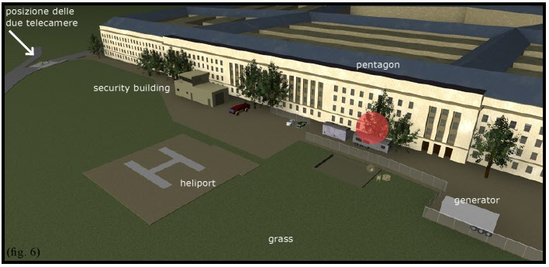

Red dot = The alleged impact point of plane on 9/11. The fourth-below photo is of the lawn just to the right/south of the ‘security building’ in this graphic -- the Pentagon heliport firehouse which is over 120 feet to the left/north of the alleged plane impact point where the lawn was pristine (next photo) just after the alleged impact.

2 of 4



Pristine lawn outside the alleged plane impact point just after alleged impact

3 of 4



Location of April Gallop’s desk where a massive explosion went off at 9:30 a.m. versus the alleged 9:37:46 a.m. plane impact point.

4 of 4



Condition of the Pentagon lawn next to the heliport firehouse outside the West Wall

near the interior location of April Gallop’s desk.

**Summary:**

The official story claims that a huge Boeing 757 airliner struck the Pentagon

in Wedge One at the point of the red dot in the first graphic and yet left no wreckage on the pristine lawn just off the wall from this point as shown

in the second photo. The third graphic shows the relative locations of this same alleged ‘plane impact’ point on Wedge One claimed to have been at

9:37:46 and April Gallop’s desk *over 120 feet further left/north* in *Wedge* ***Two*** where an internal explosion destroyed the Army area where she worked and stopped her wrist watch *almost 8 minutes earlier, at 9:30* when the alleged Pentagon plane was still dozens of miles from Washington, D.C. The fourth

photo is of the massive destruction outside the Pentagon West Wall by the heliport firehouse (labeled ‘security building’ in the first graphic) effectively opposite Gallop’s desk on the inside of the Wall over 120 feet from the

official story alleged ‘plane impact’ point at the red dot.