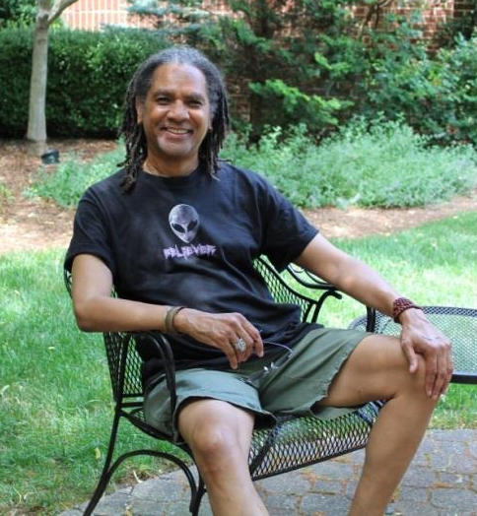
Rev. Michael J.S. Carter (L) is an interfaith minister who pastored churches in New York before moving to Asheville, North Carolina where he now serves the Unitarian Universalist congregation in Swannanoa. He has a Masters of Divinity degree from Union Theological Seminary in New York City and has authored two books – “Alien Scriptures” and “A New World If You Can Take It.”

His background is actually quite diverse. He was a professional actor in New York for 25 years. He’s a Reiki master and a diversity and anti-racism trainer who’s been recognized for his work by President Clinton. He’s also a contactee who’s been on “Ancient Aliens.”

_____________________________________________________________________________________

Man instantly healed by Pleiadian ET

Michael Carter’s leg was swollen to the size of a tree trunk but he thought it was just a muscle injury when he hobbled into his doctor’s office in late January 2013. Wrong! His right leg was so huge that the doctor asked him “Are you driving? Is someone with you?”

No one was with Michael so the doctor told him to get in a cab and go immediately to a nearby facility for an ultrasound.

“I went there and they told me I had one continuous blood clot from my ankle to the groin area and if it burst it would be the end of me,” Michael says. “I asked if it would hurt and they said I would never know what hit me.”

In an effort to dissolve the monster clot, Michael’s doctor put him on the blood thinner Coumadin. “And I was injecting myself in my stomach with another blood thinner.”

About five months later when July 4th rolled around, Michael’s leg was still badly swollen but a miracle was about to happen.

“I went to bed early and was tossing and turning,” he says. “I usually sleep on my stomach and I turned my head and there was a being in my room. He was almost as tall as my ceiling, maybe seven feet tall. He was very pale with blond hair that almost touched his shoulders and his eyes were blue.

“He’d been standing there no more than 30 seconds because I could feel his presence. He was wearing a brown robe like monks used to wear back in Renaissance times. It had a little cord belt and the hood was not on. He was very well built. I could see his muscles through the robe; that’s how built he was. At his neckline, a sky blue shirt was peeking out.

(R) Cartoon illustration of Renaissance Catholic monk
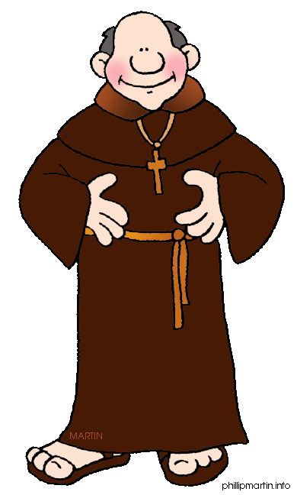

“He looked at me; I looked at him. Then he stuck his hand out toward me and an apple green light came out from the palm of his hand and hit me in my stomach area. He said nothing and I didn’t feel anything. Then he dissolved right before me. His molecules just dissolved.

“When I got out of bed, I looked down and my leg was completely normal. Believe me; I couldn’t wait to share my out-of-this-world miracle with someone. So I called Preston Dennett, a friend who lives on the West Coast and would still be up.

“I said, ‘Hey, man, since you’ve written a book about UFO healings, let me tell you what just happened to me.’ When he heard my story, he said ‘Wow! Do you mind if I put that in my next book?’ Of course I didn’t mind. His earlier book ‘UFO Healings’ is like a Bible to me.

“About a week after that, I was meditating and in my third eye two Pleiadians showed up.
They had longer blond hair and were wearing blue tight-fitting shirts or suits; I don’t know which because I could only see them from the pecks up. My eyes were closed but I blinked them open and shut and the two were still there. Then they just faded away. I took it as a way of letting me know they were around me.

“As for my doctor, he seemed so befuddled by my instant healing that all he could do was press me with questions: ‘What happened? How did this happen? How did it happen so quickly?’

“I wasn’t going to tell him what actually happened, so I said, ‘Listen, I don’t know how it happened but aren’t you happy for me? Aren’t you happy I don’t have the clot anymore?’”

