WAKE UP AMERICA!
YOU ARE BEING PLAYED!

The Truth About COVID-19

COVID-19 has been found to be a type of flu (coronavirus) with an estimated 99.9% survival rate across all age groups with the highest risk groups of over 65 estimated at 99.6%.

The ‘pandemic’ is a complete lie that has been told to you. There are global agendas behind the declaration of the COVID-19 ‘pandemic’, to benefit certain foreign individuals and companies financially and to gain control of populations.

COVID-19 was long pre-planned in documents and simulation exercises emanating from the eugenist, Bill Gates, George Soros, and the Rockefeller Foundation for the purpose of implementing a global monetary reset, digital currency, technocracy, and totalitarian government under the guise of socialism and environmentalism.

The ‘pandemic’ was used to influence the 2020 US election cycle, and it is being used to remove civil liberties, destroy economies, close down small and medium businesses, separate, isolate, and terrorize family members, impoverish people, destroy jobs, and create psychological and emotional unrest within the people.

Here are the facts:
- The COVID-19 virus has never been isolated. The COVID-19 virus does not pass Koch’s postulates, which, scientifically, is a requirement for it be termed a microorganism or pathogen. The CDC has failed to provide test and culture samples for which to compare this virus to. COVID-19 is a type of cold/flu virus. Samples that have been labeled as COVID-19, actually isolated Influenza A or Influenza B.
- The WHO has falsely declared a pandemic in relation to COVID-19.
- The COVID-19 death statistics have been manipulated. US and Worldwide Mortality is at a lower level now than in previous years.
- The PCR Test is corrupt and unreliable. It was never designed as a diagnostic test, and it gives up to 85% false positive results. It cross reacts with other viruses, including the one that causes the common cold. False positives also occur in healthy individuals. Cases, admissions, and deaths have largely been based on this unreliable test.
- The WHO lowered PCR test cycles on inauguration day, coinciding with vaccine release. The elevated test cycles contributed to false positive test results.
- Hospitals receive monetary benefits based on the number of COVID-19 deaths they report. The illusion of a pandemic is fueled by the fact that doctors and hospitals are being forced to attribute virtually every death to COVID-19. Deaths due to cancer and heart disease decreased dramatically this past year, because the deaths were being reported as COVID-19 deaths instead.
- Over 100,000 doctors have now come out world-wide to confirm that COVID-19 is a hoax.
- The number of reported cases of the seasonal flu were nearly non-existent this past year, being replaced instead with COVID-19 cases.
- The CDC illegally inflated the COVID-19 fatality number by at least 1,600% throughout the election, and “violated multiple Federal laws” according to a study published by the Public Health Initiative of the Institute for Pure and Applied Knowledge.
- Mask wearing has NOT been shown to help stop the spread of respiratory diseases, and in fact can lead to a higher risk of developing a respiratory infection. Masks have been shown to increase the level of CO2 and reduce the level of oxygen to the mask-wearer, contributing to illness and disease. They are also commonly contaminated with other germs, which are directly breathed in and cause illness.
- Fauci has publicly stated that the wearing of masks during the 1918 Influenza pandemic contributed to millions of deaths caused by bacterial pneumonia. He has also stated that masks are not effective for stopping the spread of illness.
Are you Considering the COVID-19 Vaccine?

- Did you know that we have never successfully vaccinated against the coronavirus?
  - No successful vaccine against any coronavirus has ever been developed. Scientists have been trying to develop a SARS and MERS vaccine for years, and have repeatedly failed due to the severe reactions and hypersensitivities that develop.
- Did you know that it typically takes 5-10 years to fully develop a vaccine?
  - None of the current vaccines for COVID have gone through proper trials. They are currently in experimental phases only.
- Did you know that the COVID “vaccine” is based on new technology, which has never been approved for use on humans before?
  - Traditional vaccines work by exposing the body to a weakened or killed strain of the virus/bacteria responsible for causing the disease. mRNA technology works by injecting viral mRNA into the body, where it replicates inside your cells, and can potentially modify our own genetics. These types of vaccines have been the subject of research since the 1990’s, however have never been approved for use in humans.
  - In previous studies using this technology, the vaccine repeatedly failed during the animal trials due to the significant number of adverse events and deaths which resulted.
- Did you know that the pharmaceutical companies cannot be sued if the vaccine hurts or kills someone?
  - Because the vaccine is experimental and only in a trial phase now, the manufacturers are not liable for any morbidities or mortalities that occur.
  - Employers, corporations, and small businesses, on the other hand, can be held liable for injuries incurred by the vaccine if they mandate or force their employees or customers to receive them.
  - There is no informed consent. Persons receiving the vaccine are technically entering into a clinical trial.
- Did you know that the FDA has no plans to develop a database for post COVID-19 vaccination deaths?
  - The number of deaths post-vaccination can be submitted to the Vaccine Adverse Event Reporting System (VAERS), however it is estimated that less than 1% of adverse events and deaths are being reported to VAERS.
- Did you know that 99.8% of people survive COVID without any treatment?
  - The CDC and WHO have massively inflated the number of COVID-19 cases and deaths, according to new peer reviewed studies.
  - COVID-19 is no more harmful than the seasonal flu, and there is an effective treatment for high-risk individuals.
- Did you know that there is a safe and effective treatment for COVID-19?
  - Studies have shown that hydroxychloroquine (AKA Plaquenil) can significantly improve COVID-19 patient outcomes. Vitamin C, Vitamin D, Zinc, and Ivermectin, are also among effective treatments.

What You Can Do!

Step 1: Take off your masks! Show your beautiful smile to others. By taking a stand, you are emboldening others to do the same.

Step 2: Get informed about the facts on COVID and the experimental COVID vaccine! Sadly, you won’t find this information from our mainstream media. You have to do your own research. There are many credible sources available from which to get information. Start by reviewing the references provided here.

Step 3: Share this information with your friends and family! Our freedoms are being stripped away from us like never before in the history of this great nation. We need to stand for America, stand for what is right, and we need to speak truth!

REFERENCES:

America’s Frontline Doctors https://www.americasfrontlinedoctors.com

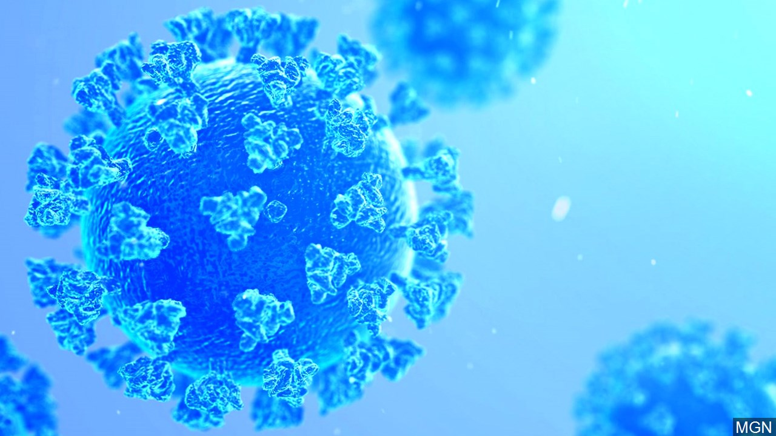
Covid Medical Network
https://covidmedicalnetwork.com/default.aspx

Children’s Health Defense
https://childrenshealthdefense.org/defender/

Concerned Lawyers Network
https://concernedlawyersnetwork.net/

World Doctors Alliance
https://worlddoctorsalliance.com/

COVID-19 Data Collection, Comorbidity & Federal Law: A Historical Retrospective; Henry Ealy et al. An Institute for Pure and Applied Knowledge (IPAK)Public Health Policy Initiative (PHPI); Science, Public Health Policy, and The Law Volume 2: 4-22October 12, 2020

“Leading Corona researchers admit that they have no scientific proof for the existence of a virus”
translated by Corona Investigative July 31, 2020
https://telegra.ph/Leading-Corona-researchers-admit-that-they-have-no-scientific-proof-for-the-existence-of-a-virus-07-31

“Peruvian Court Rules Bill Gates, George Soros and Rockefeller Family “CREATED” Coronavirus Pandemic”; TheTrueReporter.com, Trump.news, VerietyInfo.com, NaturalNews.com, SeattleTimes.com

The Truth About COVID-19

