https://www.youtube.com/watch?v=B4m7YozDd-8

From 3:13 min. to 3:39 – 3D Graphic and Photos of The Tomb of Osiris
At 4:03 min. – Cut-away of what’s under the Sphinx and that area of the Plateau showing the Shaft to the Tomb of Osiris, originally called ‘Campbell’s Tomb’.

The 'Tomb of Osiris' is located approx. beneath the large square opening at the rear of the Sphinx visible in the below aerial Photo: mb: 'The Tomb of Osiris'.
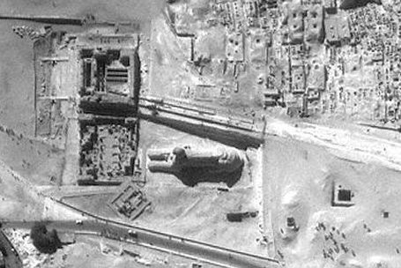

Zahi Hawass and his team performed an excavation of the Osiris Tomb in 1999. At that time, the water table on the Plateau had lowered to the point that a thorough excavation was possible, although groundwater still flooded the lowest areas. Constant pumping operations were required to reach the very bottom chamber of the complex. Hawass' team revealed the layout of the shaft and chambers, comprising three different levels, as seen in the following images (from Hawass, 2007):
Below: Schematic diagram of the tunnel system showing the 'Tomb of Osiris' approx. 30m beneath the rear of the Sphinx:

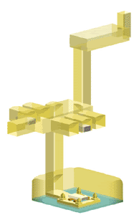
The granite lid being lifted:
[Scroll down after Photo for more]
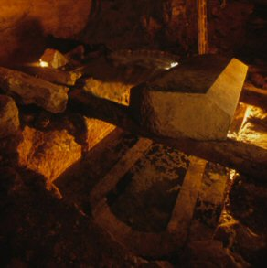
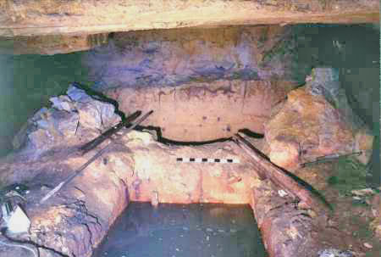
Side view showing the remains of the four corner columns.
Hawass, 2007:
The channel surrounding the emplacement in the lowest level seems to have been deliberately designed so that groundwater would fill it, making the emplacement in the centre into a sort of island. This configuration could represent the primeval waters of Nun, which covered the world at the time of creation, with the island in the center representing the first mound of earth to emerge. The water further symbolizes the connection of Osiris to fertility and rebirth. The emplacement with a large sarcophagus in the centre and a pillar at each corner (perhaps representing the four sacred legs of the god as described in later texts) is very similar to the configuration of the Osireion of Seti I at Abydos'.
'We were surprised to find that there was also some red polished pottery with traces of white paint, which probably dates to the 6th Dynasty. the earliest artefacts found inside date to Dynasty 6.
'I believe that the Osiris Shaft is what the Greek author Herodotus, the ï¿½father of history,ï¿½ was talking about when he said that Khufu was buried on an island in an underground chamber, located in the shadow of the Great Pyramid and fed by a canal from the Nile'.
'I made my second discovery from this excavation after moving the lid of the sarcophagus. I found inscribed in the ground the hieroglyphic word "pr", meaning "house." It is known that the Giza plateau was called "pr wsir nb rstaw", or "the house of Osiris, Lord of Rastaw." "Rastaw"(rostau) means the 'Mouth of the passages".
What is now called The Tomb of Osiris was originally called Campbell's Tomb named after Colonel Patrick Campbell, the British Consul who supported the work of Howard Vyse and Giovanni Caviglia at Giza), though Campbell didn’t excavate the entire depth of the shaft to the lowest level with The Osiris sarcophagus. It is a matter of record that in 1830 Colonel Vyse found this very wide shaft (it is thought that at least 10,000 tonnes of limestone had been dug out of it!), almost square (9m x 8m), surrounded on all sides by a deep trench. On 11 February 1837, when the sand had been cleared out of it to a depth of more than 30m, he reached what he thought was the bottom, where he recorded finding a number of sarcophagi, one of which is made of basalt, now resides in the British Museum. His excavation revealed only the upper parts of the tomb, which consisted of a secondary burial, generally agreed to be from the 26th dynasty.
What is now called the 'Tomb of Osiris' was excavated again in 1933-1934 by Dr Selim Hassan who noted that the first chamber led to a second, in which there were seven niches, each containing a basalt sarcophagus, two of which were substantially larger than the others (Today only two sarcophagi remain). Hassan describes the finding of the opening Toto the shaft complex in the sixth season of his work, and went on to report:
'Upon the surface of the causeway they first built a platform in the shape of a mastaba, using stones taken from the ruins of the covered corridor of the causeway. In the centre of this superstructure they sank a shaft, which passed through the roof and floor of the subway running under the causeway to a depth of about 9.00 m. At the bottom of this shaft is a rectangular chamber, in the floor of the eastern side of which is another shaft. This descends about 14.00 m. and terminates in a spacious hall surrounded by seven burial-chambers, in each of which is a sarcophagus. Two of these sarcophagi, which are of basalt and are monolithic, are so enormous that at first we wondered if they contained the bodies of sacred bulls.
In the eastern side of this hall is yet another shaft, about 10.00 m. deep, but unfortunately it is flooded. Through the clear water we can see that it ends in a colonnaded hall, also having side-chambers containing sarcophagi. We tried in vain to pump out the water, but it seems that a spring must have broken through the rock, for continual daily pumping over a period of four years was unable to reduce the water level. I may add that I had this water analysed and finding it pure utilized it for drinking purposes' (Hassan 1944: 193).
(Plan of the second level sarcophagi chamber http://www.ancient-wisdom.com/Images/countries/Egyptian%20pics/osirisshaft.jpg )
Hassan makes mention of a "subway running under the causeway." All this term refers to is a small tunnel burrowed under the causeway of Khafre's pyramid complex. This tunnel probably served as a shortcut for priests and other temple personnel to bypass the causeway; a similar bypass was excavated under the remains of Khufu's ruined causeway, to the north (Hawass 2007: 395). Hassan's journal illustrates what has become an unfortunate trend when it comes to important discoveries, namely the discrepancy in the number of sarcophagi he saw and the number present today. The Giza site has been under close scrutiny by the Egyptian authorities since Hassan's time, yet there are now five sarcophagi missing, yet no questions have been posed as to what had happened to the other five. [One is in the British Museum.]

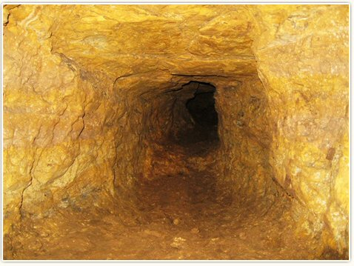
(Photo Credits: http://www.richardgabriel.info/OSIRIS.html )
What remains one of the most interesting unexplored features of the Osiris shaft is the narrow tunnel that extends from the northwest corner of the lowest level. This tunnel appears carved but is only large enough to admit a young child at its entrance, and further along, it becomes filled with mud. At about 6.5 meters, the a branch splits off the tunnel. A camera has been sent 10.5 meters into this branch before it became too narrow and muddy for the rovers to go any further. The main tunnel has been determined to extend for a total length of about 21 meters, where it seems to end, although it has been impossible to determine this with certainty.

