Benghazi Tragedy – Using Vocal Profiling to evaluate issues of truth, integrity and intention

Note: Most regular followers of the nanoVoice software are aware of how this software can be used to identify personality traits including attitude, honesty and attempts at cover up. It is important to observe that what is not obvious in a nano evaluation is just as important as what is present. If you are not familiar with the nanoVoice software, there is a two hour class and other educational materials available to the public at nanoVoice.org because
YOU HAVE A RIGHT TO KNOW.

Hillary Clinton (05-09-13) as US Secy of State speaks at body exchange for Benghazi victims – about the video she says is responsible. Video Link: http://www.youtube.com/watch?v=QSooz2wXpes
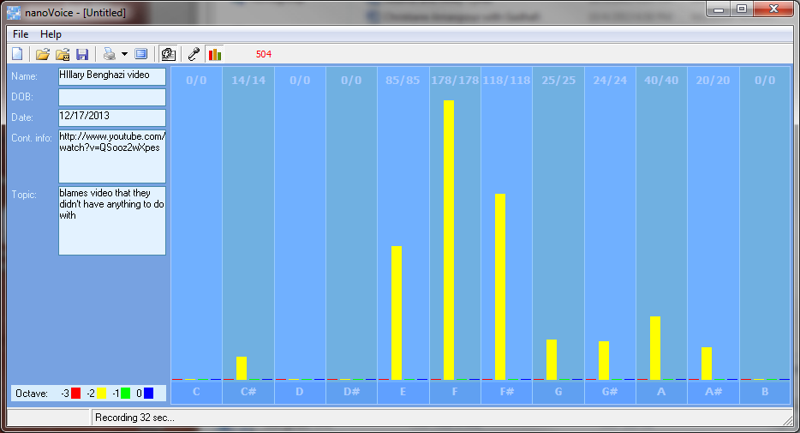
Vocal Profiling evaluation of Hillary Clinton: Average # hits: 42

Overt Perspective: Intellectual for a planned purpose
Major Emphasis: whole to right-brained, intellectual perspective presenting a plan using words that are not balanced with management view. Notes of E and A# are not balanced; indicating possible deception.
Lost Emphasis: ego, help to/for others, outcome for all concerned, useful physical outcome

Computer Print-out

Points of Importance, Attention and Consequence

It is easy for you to see the faults in others but don't always know how to get your point across politely. You push yourself and others to finish the job. You love new ideas that mean you can have a project to work on. If you ever had to lie to see justice done, you would do it but your sense of justice does not always jive with the law.

Your graph indicates an unbalance between appropriate perception and action management. The ability to quickly assess an intellectual situation levels is noted.

Your highest note is three times the average indicating an over-emphasis on perception. The ability to see the flaws in a plan resides with this chart. Your highest note deals with expression through words both written and oral especially for future/fantasy layers.

You can sometimes do too much for others in the hopes of helping them change. You may be caught once in a situation but you aren't often caught twice without a proper answer.

Points of Communication, Complications and Complaints

You have the ability to use words very creatively. You have the ability to inspire people using stories and demonstrations. You have a strong sense of justice, fairness and Truth from a future perspective. You can get satisfaction out of being able to help others move in the direction that you see as positive.

As a natural leader, you sometimes get stuck with more than your share of the work. You do what you do in your mind first, based on your own agenda of what you see in the future. You know how you want things to look and work to make it so.
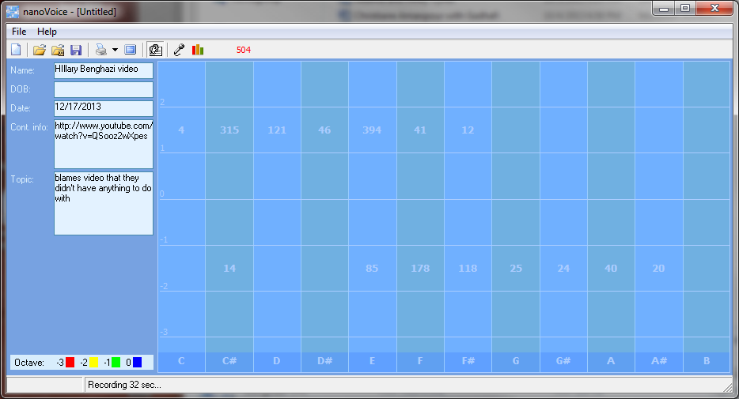
Voice analysis time domain charts can be taken very literally when using the numeric grid. When the filled blocks are fragmented so too are the vocal frequencies of the speaker. Scattered frequencies indicate disparate thought patterns. The lowest, most filled layer (in this case -2) indicates foundation. When separated in the manner shown below, there is a disconnect between foundational and the higher levels of the graph. Frequencies separated in this manner indicate a fantasy or impending future perspective not to be revealed at this time.
Emphasis in the below numeric grid indicates a fantasy/impending perspective of justice/fairness/truth mixed with words meant to move the listener to the fantasy/impending future as envisioned by the speaker. Little to no ego is involved nor is a perspective that would be security for humanity as a whole. The words spoken as the overt message do not match the furtive message of “justice my way” nor will the anticipated outcome be for the benefit for others.
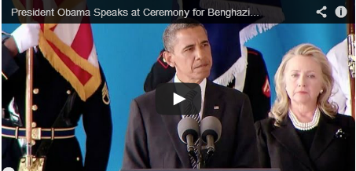
Obama and Hillary at body exchange for Benghazi victims (05/09/2013):
Ambassador Chris Stephens, Glen Doherty, Tyrone Woods, Sean Smith were being brought back to the US for burial.
After Hillary declared that the US had nothing to do with video being blamed for Benghazi, Obama speaks about protecting the security of our citizens and nation. Link: http://www.youtube.com/watch?v=QSooz2wXpes
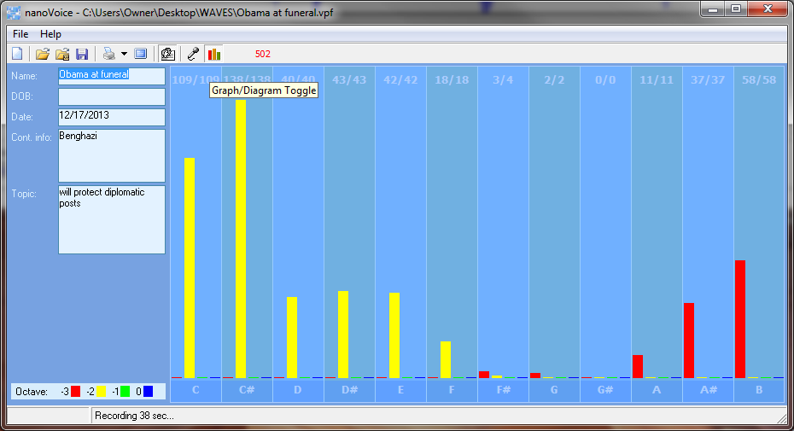
Overt Perspective: Intellectual Justice (3X’s above average), Ego Average: 42
Major Emphasis: left brain, intellectual, ego, truth/justice/fair (over emphasized – possibly “my way” attitude of bullying when you consider the double average of ego). There is some showing of caring for the masses.
Least Emphasis: caring out plans to a positive, useful conclusion

Computer Evaluation

Points of Importance, Attention and Consequence

Others see you as having leadership potential but they may resent you for the same reason. You have high ideas and expect the same of others.

Your highest notes show an overexpression of justice, fairness and Truth connected to ego. Self-Power is amply expressed. There is emphasis on service to humanity expressed through over expression of ego. Your feelings and desire to help others is average.

Structure is not required for you to be comfortable. Ideas come to you in very odd moments when you are distracted by a required task. Being able to prioritize what needs to be done emotionally is not always easy for you.

Points of Communication, Complications and Complaints

You work well with others and are often put in a leadership position. You tend to teach from an intellectual perspective.

You can easily be distracted from carrying out your plans by a more exciting prospect. You would like to have more time to spend on private spiritual issues. You have a hard time prioritizing what you want to do first.
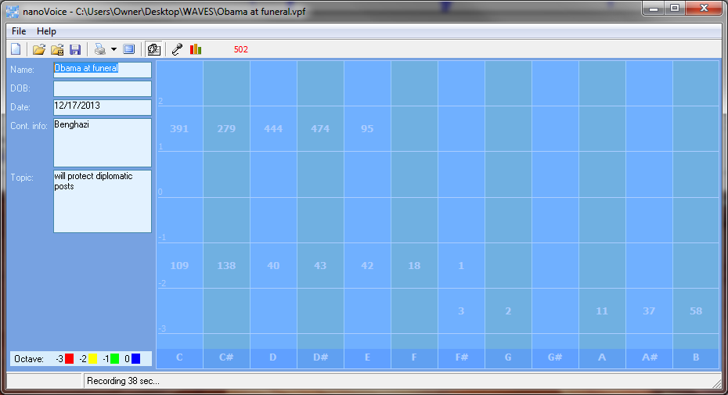
The foundational octaves of this chart lack emphasis in conceiving/achieving a balance between perception and action that would culminate in a useful, physical outcome. Like the numeric grid of Hillary Clinton, the octaves and segregated into two distinct rows. This indicates withholding of information that is being kept separated from what is being actually conveyed by the words themselves.

Emphasis is on fantasy or future levels of helping others; second only to a large dose of fantasy/future ego. The perception is that he is helping now in a way that will be rewarding for others in the future. He believes what he is saying but knows it is not true, yet. He wants what is best, his way.

The notes of A# and E are nearly equal in amount but not in octave. This would likely indicate that words spoken are not the message but the message is being perceived as to be what the future will be.

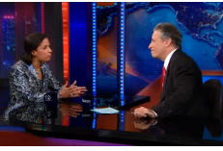
Susan Rice http://articles.latimes.com/2013/feb/15/entertainment/la-et-st-susan-rice-benghazi-daily-show-20130215

Susan Rice, US Ambassador to the UN, speaks with TV Host, Jon Stewart about the talking points she delivered on several Sunday talk shows blaming a little known anti-Christian video on the attack in Benghazi.

Overt Perspective: Intellectual information broker
Major Emphasis: left brained, lacks foundation of her knowledge, verbally providing a plan of perception and action not based on self-knowledge
Least Emphasis: no plan for carrying out anything but information delivery, not attached either physically or emotionally – no sense or need for justice, truth or fairness - lacks creative input
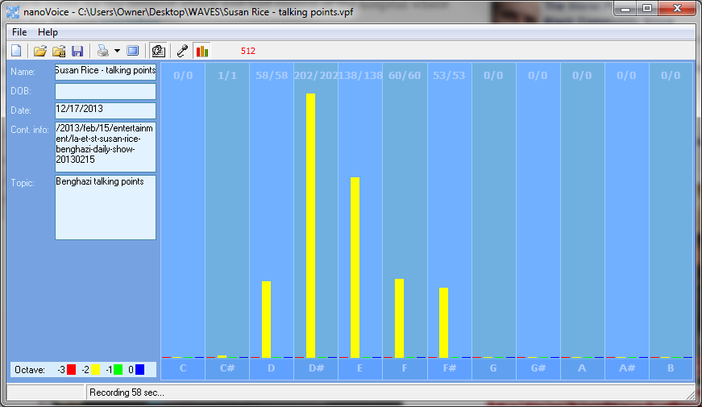
Computer Evaluation Average # of hits: 42

Points of Importance, Attention and Consequence

You have a high degree of intuition when it comes to listening to what people are not saying.

If you ever had to lie to see justice done, you would do it but your sense of justice does not always jive with the law. It is easy for you to see the faults in others but don't always know how to get your point across politely. (Shares these two traits with Hillary Clinton.)

The need for balance between self-expression and self-worth in obvious in this chart. You have the ability to express yourself well through words both written and oral in overt as well as for the creations of future scenarios. This differs from Hillary in which Hillary’s strongest expression is in fantasy/future layers.

The highest notes expressed are associated with the use of words to integrate appropriate perception and action. The ability to assess a situation quickly resides with this note.

Your leadership ability is hampered by lack of opportunity. You don't always express your sense of confusion to the appropriate person. Ideas come to you in very odd moments when you are distracted by a required task. (She shares this trait with Obama.)

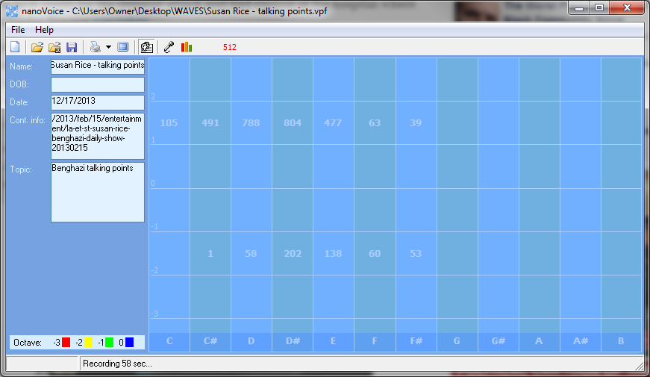
Points of Communication, Complications and Complaints

The speaker understands that trust should be earned but often trusst without reservation. The best lessons are taught by action and example. You have the ability to use words very creatively. You have the ability to inspire people using stories and demonstrations.

You can easily be distracted from carrying out your plans by a more exciting prospect. (Obama also has this trait.) As a natural leader, you sometimes get stuck with more than your share of the work. You know how to get things done but don't always have the time to deal with the details.

Comparison of Rice, Hillary and Obama talking about Benghazi being instigated by a video
This shows the plan started with Hillary
Obama serves his own ego and his idea of justice
Rice is the information broker
Dylan Davies aka Morgan Jones discussing Benghazi compound SECURITY CONCERNS prior to the attack
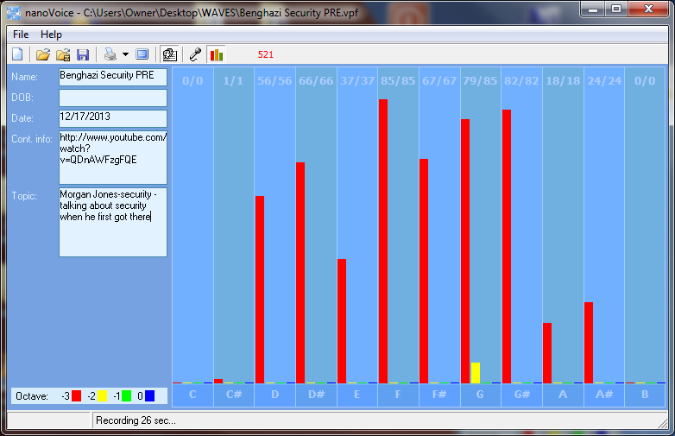
Overt Perspective: Reactive
Major Emphasis: whole brained, design and implement a useful conclusion that supports others
Least Emphasis: lacks ego, lacks martyrdom

Of all charts evaluated for the purposes of report, this chart has the most solid foundation. Indications of the integration of appropriate perception and action are obvious. This speaker has the ability to access a physical situation quickly. Fantasy/future layers deal with helping others with minor support in fairness/truth and information brokering.
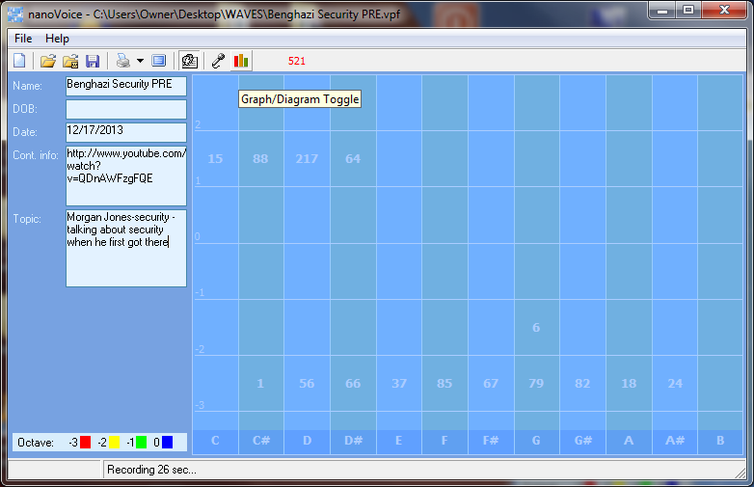
Morgan Jones/Dylan Davis – talks about speaking another person who was present during the Benghazi attack
Overt Perspective: Reactive, emphasis is on physical outcome
Major Emphasis: right brained, concern over management of a physical situation
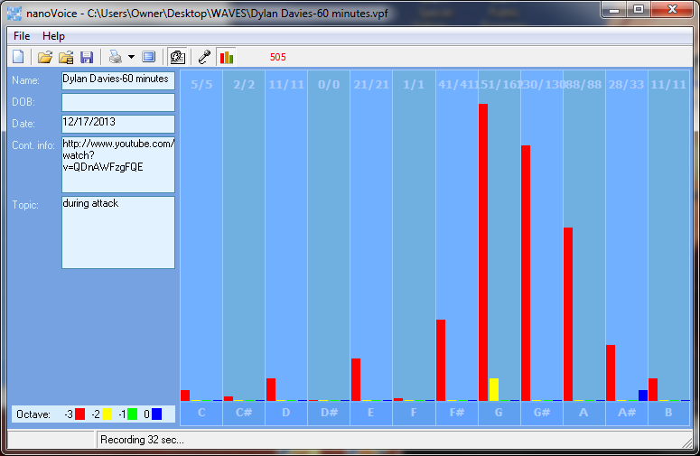
Least Emphasis: lacks ego, lacks martyrdom, lack self-approval, lacks verbal response, lacks plan but is moving into physical action anyway.
Computer Evaluation
Points of Communication, Complications and Complaints

You have the ability to organize and prioritize in your head. It may not look that way to others but it is your mode of operation. You like to organize yourself so that everything is at hand and easy to utilize. It is particularly bothersome when people use or borrow your property without permission.

You are capable of pushing yourself to get things done. Creating new projects from the ideas you generate is rewarding. You take pleasure in changing things for the better.
You can be talked out of your own opinions if solid evidence is presented because you are open to new ideas. You can sometimes feel criticism too quickly and too personally because you want to be more aware of self-issues.
You can be very hard on yourself - taking blame or responsibility - that does not really reside with you. You sometimes fail to defend yourself because you don't want to criticize the opinions of others. In your desire to be of value to the growth of others you will learn that doing for others too quickly is not good for them.
You wish for the best which sometimes leads to statements of hope instead of statements of fact. You may need more than one chance to express yourself to get it right.
You do for others before you do for yourself. It is a struggle sometimes to decide what you really think and what part belongs to someone else because you are so empathetic.
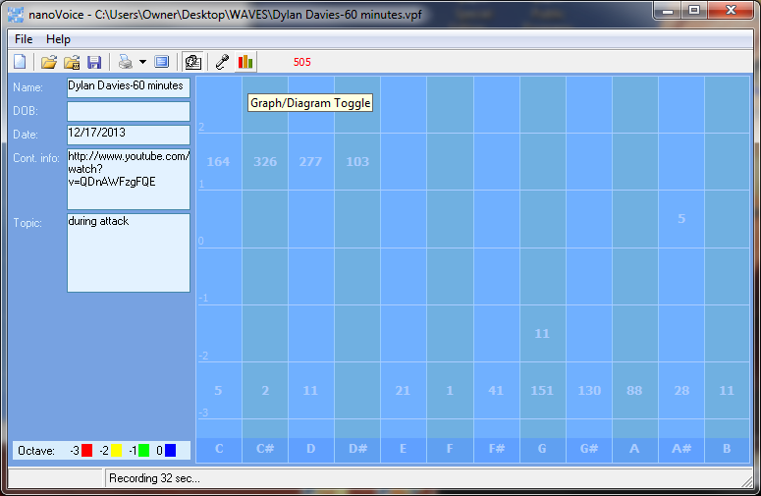
Summary of intent via BioAcoustic Personality software:
Both Obama and Hillary Clinton have an intellectual “story telling” attitude toward the Benghazi deaths. They are actively withholding information. They have hope that all will turn-out well but that hope is not based on any foundational evidence. Ego and justice – their way – is emphasized.
Rice is doing what she was asked to do for personal gain. She did not ask nor did she want to know the truth of the situation. Her motivation is an elevation of her own position.
Morgan Jones is foundational in his thinking and planning. He is concerned for others. He is ready to act for physical benefit of others. There is some fantasy ego involved in his telling of the phone conversation but very little in his warnings about the lack of safety for the compound that was attacked.

Dylan Davies aka Morgan Jones discussing Benghazi compound SECURITY CONCERNS prior to the attack
Overt Perspective: Reactive
Major Emphasis: whole brained, design and implement a useful conclusion that supports others
Least Emphasis: lacks ego, lacks martyrdom

Of all charts evaluated for the purposes of report, this chart has the most solid foundation. Indications of the integration of appropriate perception and action are obvious. This speaker have the ability to access a physical situation quickly. Fantasy/future layers deal with helping others with minor support in fairness/truth and information brokering.

Morgan Jones/Dylan Davis – talks about speaking another person who was present during the Benghazi attack
Overt Perspective: Reactive, emphasis is on physical outcome
Major Emphasis: right brained, concern over management of a physical situation
Least Emphasis: lacks ego, lacks martyrdom, lack self-approval, lacks verbal response, lacks plan but is moving into physical action anyway.
Computer Evaluation
Points of Communication, Complications and Complaints

You have the ability to organize and prioritize in your head. It may not look that way to others but it is your mode of operation. You like to organize yourself so that everything is at hand and easy to utilize. It is particularly bothersome when people use or borrow your property without permission.

You are capable of pushing yourself to get things done. Creating new projects from the ideas you generate is rewarding. You take pleasure in changing things for the better.
You can be talked out of your own opinions if solid evidence is presented because you are open to new ideas. You can sometimes feel criticism too quickly and too personally because you want to be more aware of self-issues.
You can be very hard on yourself - taking blame or responsibility - that does not really reside with you. You sometimes fail to defend yourself because you don't want to criticize the opinions of others. In your desire to be of value to the growth of others you will learn that doing for others too quickly is not good for them.
You wish for the best which sometimes leads to statements of hope instead of statements of fact. You may need more than one chance to express yourself to get it right.
You do for others before you do for yourself. It is a struggle sometimes to decide what you really think and what part belongs to someone else because you are so empathetic.
Summary of intent via BioAcoustic Personality software:
Both Obama and Hillary Clinton have an intellectual “story telling” attitude toward the Benghazi. They are actively withholding information. They have hope that all will turn-out well but that hope is not based on any foundational evidence. Ego and justice – their way – is emphasized.
Rice is doing what she was asked to do for personal gain. She did not ask nor did she want to know the truth of the situation. Her motivation is an elevation of her own position.
Morgan Jones is foundational in his thinking and planning. He is concerned for others. He is ready to act for physical benefit of others. There is some fantasy ego involved in his telling of the phone conversation but very little in his warnings about the lack of safety for the compound that was attacked.

STATEMENT OF FACT: The information herein contains opinions concerning correlations between personality traits and frequencies found within the voice. The computer printouts are generated by a computer using fast Fourier transforms and voice spectral analysis developed by the Institute of BioAcoustic Biology – a non-profit research organization: SoundHealthOptions.com – 740-698-9119.
Message sent to Simon & Schuster after 60 minutes appearance by Dylan Davies aka Morgan Jones
Link: http://mediamatters.org/print/blog/2013/11/14/report-cbs-benghazi-source-has-disappeared-afte/196904
In the message, which was sent on Friday morning to Simon & Schuster vice president Jennifer Robinson, Davies said someone had threatened to harm his family if he continued to defend his account of events in Benghazi to the media. The email was obtained by The Daily Beast.
The timing could not have been worse. Last week CBS’s 60 Minutes, which had interviewed Davies for a report on Benghazi that aired last month, apologized to its viewers and pulled the report. After 60 Minutes walked away from Davies, Simon & Schuster on Friday announced they would be pulling the book from stores.

In the midst of all of this, Davies has not spoken to the media. Friday’s email, which was sent before Simon & Schuster announced its decision to pull the book, provides some clues on his decision to stop talking.

Davies wrote that on Sunday November 3 at 4:00 a.m., he was hand-delivered a note to his home address in Wales that said, “Stop talking now or your wife and son will disappear.” In the email to Robinson, he went onto say, “Due to this threat I will not discuss the book with anyone under any circumstances for the foreseeable future, I am not prepared to put my family in danger. I stand by my story however I understand that it continues to be rubbished, which I expected.”

Links for Benghazi evaluations
http://news.yahoo.com/exclusive--why-dylan-davies-disappeared-202302775.html
http://www.youtube.com/watch?v=QSooz2wXpes Hillary & Obama blame video
http://www.youtube.com/watch?v=QDnAWFzgFQE preacher - start at 10:20
http://worldnews.nbcnews.com/_news/2012/09/20/13992235-us-spends-70000-on-pakistan-ad-denouncing-anti-muslim-film?lite US spends 70,000 on anti muslim film
https://www.youtube.com/watch?v=XtNu6E7c4vA Hillary Obama in Pakistan
http://www.breitbart.com/Big-Journalism/2013/10/28/CBS-60-Minutes-Try-to-Atone-for-Benghazi-Cover-up lara Logan - apology
http://communities.washingtontimes.com/neighborhood/time-choosing/2013/may/15/benghazi-showcase-lies-and-incompetence-obama-and-/ all the lies
http://www.youtube.com/watch?v=ow2bl5BQsFE Hillary what difference does it make
http://www.youtube.com/watch?v=-vxg4yhGDT8 susan rice – talking points
http://articles.latimes.com/2013/feb/15/entertainment/la-et-st-susan-rice-benghazi-daily-show-20130215 LA time susan rice
http://mediamatters.org/print/blog/2013/11/14/report-cbs-benghazi-source-has-disappeared-afte/196904
http://www.thedailybeast.com/articles/2013/11/14/why-dylan-davies-disappeared.html
http://www.slate.com/blogs/weigel/2013/11/14/the_60_minutes_benghazi_source_just_sort_of_lies_about_everything.html
Dylan Davies, the British contractor whose contested eyewitness account of the assault on the U.S. compound in Benghazi caused a firestorm, sent an email to the publisher of his new book telling them he was going dark. ... Davies wrote that on Sunday November 3 at 4:00 a.m., he was hand-delivered a note to his home address in Wales that said, “Stop talking now or your wife and son will disappear.” In the email to Robinson, he went onto say, “Due to this threat I will not discuss the book with anyone under any circumstances for the foreseeable future, I am not prepared to put my family in danger. I stand by my story however I understand that it continues to be rubbished, which I expected.”
http://mediamatters.org/blog/2013/11/05/fox-news-defends-discredited-60-minutes-benghaz/196749 fox news defends Morgan jones
http://www.huffingtonpost.com/2013/11/08/lara-logan-apologizes-60-minutes-benghazi-correction_n_4239046.html lara logan apology – set up to destroy Morgan Jones
http://www.deadline.com/2013/11/cbs-news-investigating-new-information-that-undercuts-its-60-minutes-benghazi-report/

Thank you for taking the opportunity to experience the nVoice™ computer program. As you speak into the microphone, the computer will catalog your words into musical note patterns. Your print-out will reflect the twelve notes of the musical scale – C, C#, D, D#, E, F, F#, G, G#, A, A# and B; plus the octave(s) in which you speak. The notes, octaves and general architecture of your vocal graph are used to create a computerized nVoice Personality Profile interpretation for you. Each of these notes has general characteristics which are explained in the chart below. The database used for your analysis has been developed over the last twenty years as we collected data. We would appreciate feedback as to how you think your profile matches the REAL you.
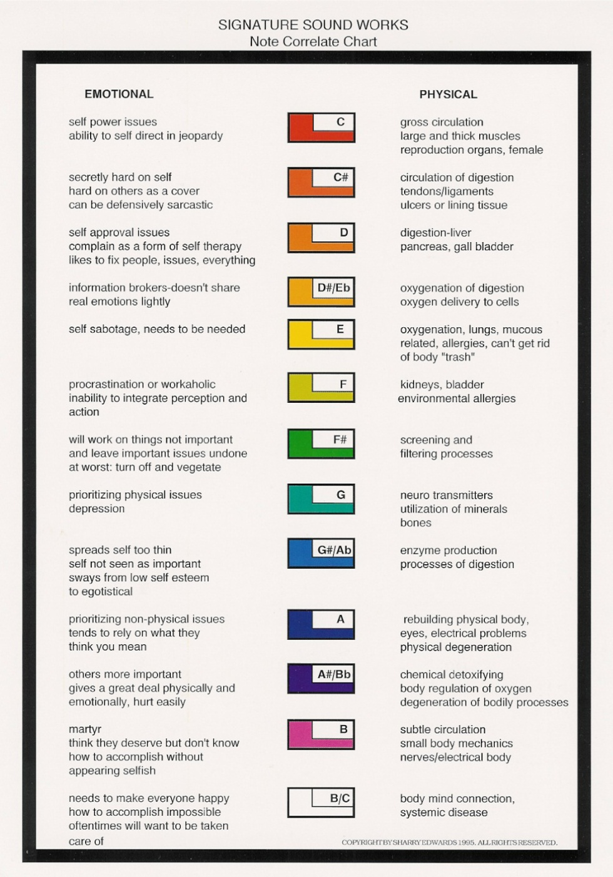
For this particular type of vocal profiling, your emotions can greatly influence the interpretation. If you would like information about a variety of subjects, take several voice samples; keeping with one subject for each voice sample. Every print-out will be “flavored” by the subject you talk about.

Remember that each written report will reflect what you say as well as what you don’t say.
Sometimes you will find conflicting statements on a report. This indicates that these same conflicts reside within your own personality. As you talk about different subjects you will be able to determine the conflicts and joys of each subject.

If you doubt the accuracy of your nVoice Personality Profile, ask a friend who will tell you the truth about how you are perceived by others.

