https://www.youtube.com/watch?v=rnGZLE_bRXM
Biden Dec 3

Recording Date: 12/03/2021

Points of Importance, Attention and Consequence
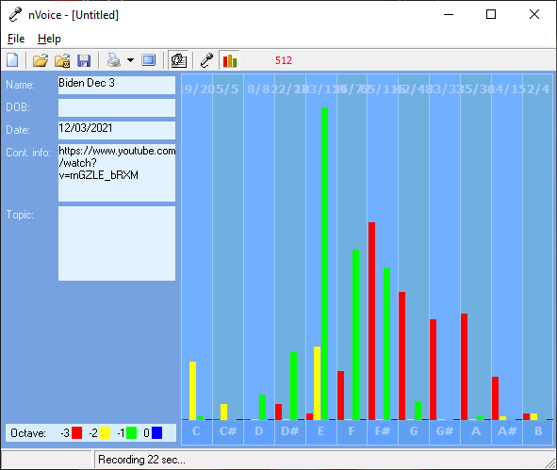
Another shift - Words expressed for an emotional purpose

Strong foundation – carrying out a plan
For the future

Very little concern for others

Very little concern for justice

Intellectual ego
Words not balanced with internal perspective.

Has a plan
Lacks emotional justice

Plan and carrying out a plan is unbalanced

You have the ability to use words to persuade the minds of others. If you ever had to lie to see justice done, you would do it but your sense of justice does not always jive with the law. Using vocal expressions to misdirect a query is easy for you.

You can use the high or low of your voice to give people direction as to how to treat you. You can convey a great variety of expressions using vocal nuance instead of words. You push yourself and others to finish the job. You love new ideas that mean you can have a project to work on. A sense of belonging is important to you. You plan well and want to see to it that your plans are carried out. It is easy for you to see the faults in others but don't always know how to get your point across politely. You expect others to take your suggestions seriously and gracefully. Nice things appeal to you and you are not averse to working hard to obtain them Your highest note deals with expression through words both written and oral. The world of creative self-expression resides with this note. Your highest note is associated with the expression of duty to work and accomplishment. The ability to see the flaws in a plan and make it right resides with this note. Your highest note is associated with the expression and integration of appropriate perception and action. The ability to assess a situation quickly resides with this note

Providing balance between what you want and what you will allow yourself, will result in harmony in your life. Those around you will allow you to give too much unless you define your own needs. You tend to do more for others than they do for you. You sometimes depend on others to support your place in the world. You can see how a situation needs to play out, but you don't want to seem interfering. You don't always express your sense of confusion to the appropriate person when others attempt to deal with you inappropriately. You can sometimes do too much for others in the hopes of helping them change. You do for others before you do for yourself. It is a struggle sometimes to decide what you really think and what part belongs to someone else because you are so empathetic. Defining your own ideals and what you want from life is the first step to not following a wrong road. You can see what is the best for others but sometimes ignore what is the best for you. You tend to learn by example.

Points of Communication, Complications and Complaints

You have the ability to convince others with words - spoken and written. You have the ability to use words very creatively. You have the ability to inspire people using stories and demonstrations. You can think well and spontaneously when the need arises. You can change mental direction in a heartbeat.

You are capable of pushing yourself to get things done. Creating new projects from the ideas you generate is rewarding. You take pleasure in changing things for the better.

You have the ability to plan for yourself and others. You can easily show others how to put a plan together. You can get satisfaction out of being able to find and correct mistakes.

Your connection to universal truths can be easily misplaced if you allow others to demand your time. Deciding to put yourself first may require considerable contemplation. Being proactive will lead you where you want to be. You like to see what others think and then add your opinion later. You have the ability to put yourself aside for others and often do.

It is hard for you to understand why people take your peaceful nature as being an easy target. As long as a rule doesn't pertain to you or yours personally, you don't often bother to object. You very much appreciate those who come to your verbal rescue.

You can be talked out of your own opinions if solid evidence is presented because you are open to new ideas. You can sometimes feel criticism too quickly and too personally because you want to be more aware of your self-issues. You can be very hard on yourself - taking blame or responsibility - that does not really reside with you. You sometimes fail to defend yourself because you don't want to criticize the opinions of others. In your desire to be of value to the growth of others you will learn that doing for others too quickly is not good for them.

Points of Cooperation, Learning, Opportunity and Growth

You are willing to spend a lot of your time making sure that others learn about integrity, wisdom and responsibility. You challenge yourself much more than others challenge you. You love seeing all the pieces fall together to make it all work.

Getting to the core of what you really believe to be the right way of life is important to you. There are times when you disregard your own needs in order to help others. It is important to you that you make a difference in the lives of others. To help them move toward a more unselfish life. You are a natural teacher by example. You have a patient outlook on life and can work toward a specific goal without regard for your own needs.

You don't mind working to make your environment a place of enjoyment and peace. Working physically toward spiritual balance needs to be a part of your life. What others have is not a concern for you.

Organizing your space in your own way is important to you. You delight in seeing the results of what you have physically accomplished. You enjoy the company of people who are comfortable with the natural environment. You have many physical sides that you present at your whim.

You have a low tolerance for meaningless conversation. You have lots of ideas but prefer to keep them to yourself until you have worked them out completely. Even when you know someone is lying you feel uncomfortable confronting them. You would like the world to be a fair place without the need for arguments.

You have good intention about bringing your plans to fruition. You seem disorganized to the casual onlooker. You would like more options about your physical surroundings.

You want it done right the first time. You have the ability to see what won't work when others present you with a plan. You like verbal excitement via words and music.

Using spirit to support your ideas is important. Exercise is particularly important to keep cellular oxygen flowing.

Stress can literally take your breath away. You have a tendency to promise more than you have time to deliver. You don't always have the energy to carry-out what you intended to do. You can get excited when you talk about an idea but can easily lose interest if you already know the outcome.

The balance of pride and a love of humanity keeps you committed and more busy than you would like. You can lose interest in a project without warning. You are likely to be put into a position to require others to finish projects because you spread yourself too thin.

You strive to bring together what others think of you with what you think of yourself. You can second guess yourself in a heartbeat. You let others convince you that your feelings are in error because you care about them and their opinions.

