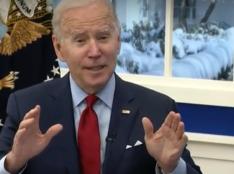
https://www.realclearpolitics.com/video/2022/01/04/biden_the_vaccinated_are_highly_protected_while_the_unvaccinated_should_be_alarmed.html
“Give it to you straight – always would” His voice is so insincere, it is a wonder he did not choke. His vocal analysis shows his intent is:

To assuage his own ego
To Plumps his egotism
He Lacks belief in own words
His brand of emotional information shows how unaware of public sentiment he really is
Ego scores are nearly double of any other motivation
Lacks concern for how to make this happen or the outcomes
The dictionary needs a scalable definition of stupid in an to attempt to cover the content of this oblivious speech

“Continues to be pandemic of the unvaccinated” - attempting to supe the public people being deliberately manipulated/dupped for political gain
Following footsteps of Macron (France) about pissing off the unvaccinated
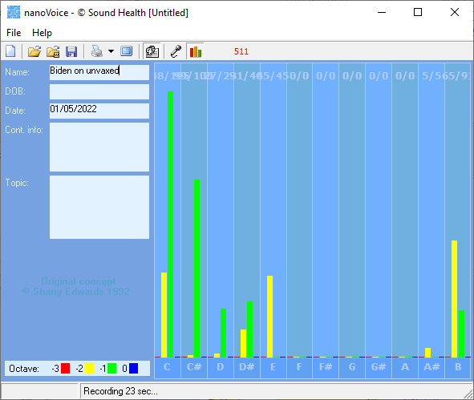
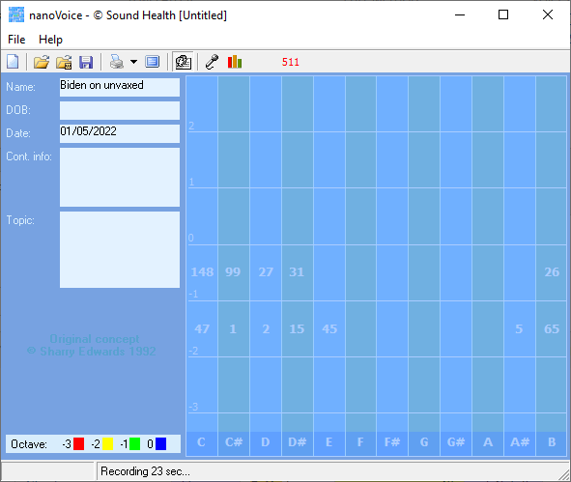
Biden on unvaxed

Recording Date: 01/05/2022

Missing Notes

You have no hits for the note(s) of: F, F#, G, G#, A. Either you did not take enough samples (100-500 is usually best) or your subject matter did not include thoughts or topics that would involve this/these note(s). See the Note Correlate Chart that appears on the Cover Page for more explanation.

Points of Importance, Attention and Consequence

Others see you as having leadership potential but they may resent you for the same reason. You have the ability to allow others to use your strength and support for their own needs. You have high ideals and expect the same of others.

Your highest note is associated with the expression of self power. The issues of circulation and stamina reside with this note. Your highest note is associated with the expression of justice, fairness and Truth. Joint, tendon and connective tissue issues, along with smooth muscle contractions, reside with this note. Your highest note is associated with service to humanity and human spirit. Your feelings and desire to help others resides with this note.

When in doubt, have the courage to go to the source and ask for clarification. You can sometimes do too much for others in the hopes of helping them change.

Points of Communication, Complications and Complaints

You work well with others and are often put in a leadership position. You have a strong sense of justice, fairness and Truth. You sometimes help others to the detriment of yourself. Your emotions run strong and can influence your health.

You do what you do for the benefit of all concerned, even if it stresses you personally. You can be very hard on yourself - taking blame or responsibility needlessly.

Biden lies a lot in support of looking more astute, intelligent and acceptable. Will be too late to get him out of any position that allows him to take away the freedoms of the American people.
He was not top of his class as he claims.
Did not receive scholarship.
He is a proven plagiarist.
https://www.shiftfrequency.com › a-scandal-free-biden-administration
There would be no "scandal-plagued single term" for President Biden. For the media (and Ron Klain) to pronounce the Biden Administration "scandal free" is akin to the NFL once denying that traumatic brain injury was rampant in football. If there is no coverage, there is no scandal.

"A Scandal-Free Biden Administration": The Media ...
https://www.nationandstate.com › 2022 › 01 › 02 › a-scandal-free-biden-administration-the-media-celebrates-a-year-free-from-political-scandal-and-press-scrutiny
There would be no "scandal-plagued single term" for President Biden. For the media (and Ron Klain) to pronounce the Biden Administration "scandal free" is akin to the NFL once denying that traumatic brain injury was rampant in football. If there is no coverage, there is no scandal.

Biden Says He's Proudest Of 'Barack And Me' That There ...
https://breakingfirst.com › biden-says-hes-proudest-of-barack-and-me-that-there-were-no-scandals-21
Biden no scandals The schmo of the United States (SCHMOTUS), former Vice President Joe Biden, sees the Obama administration as perfect. He told a voter at an NH campaign stop, ""The thing I'm am proudest of with Barack and me is that there were no scandals." Sure, they were like boy scouts.

A Bunch Of Biden Scandals Are Coming, Brace Yourselves For ...
https://www.redvoicemedia.com › 2021 › 12 › a-bunch-of-biden-scandals-are-coming-brace-yourselves-for-2022-jason-chaffetz
A Bunch Of Biden Scandals Are Coming, Brace Yourselves For 2022 - Jason Chaffetz. Although President Joe Biden promised the Democrats at their Christmas event that they would win big in the 2022 midterm elections, the poll and analysts predict a massive wave of red. And the Republicans winning back control isn't even the biggest takeaway ...

