Elon Musk

https://www.youtube.com/watch?v=V1nQFotzQMQ

aware on many levels but not necessarily using all levels. Very solid foundation – Lots of Energy to Build and manage physical reality.
Bought controlling interest in Twitter – stock went up 34% - - people trust him to do the right thing – gives public HOPE. He believes that what information people receive must flow freely.
HAS an egotistical bent toward the use of information – keeps eye on future and wants to keep it transparent – easy to read – because he doesn’t hold back his public need to be of value
Not in Biden’s loop

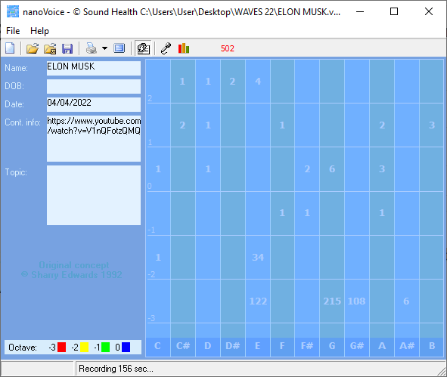

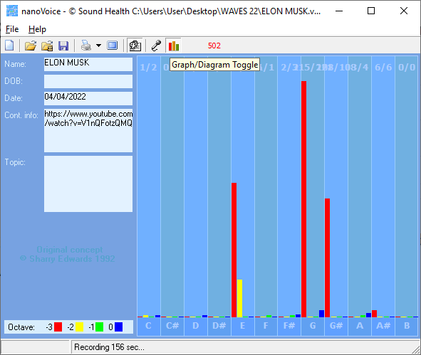

ELON MUSK

Recording Date: 04/04/2022

Missing Notes

You have no hits for the note(s) of: C#, D#, B. Either you did not take enough samples (100-500 is usually best) or your subject matter did not include thoughts or topics that would involve this/these note(s). See the Note Correlate Chart that appears on the Cover Page for more explanation.

Points of Importance, Attention and Consequence

Your stamina to get things accomplished is admirable. If you ever had to lie to see justice done, you would do it, but your sense of justice does not always jive with the law. You can be fussy about your physical space. It needs to satisfy you and no one else. Sometimes you spend a lot of energy trying to get even the smallest detail right the first time.

Your highest note is associated with the expression of what you consider to be your physical domain. Having dominion over your physical environment resides with this note. Your highest note deals with expression through words, both written and oral. The world of creative self-expression resides with this note. Your highest note is associated with the expression of physically prioritizing. Personal control over what happens in your physical environment resides with this note.

Your leadership ability is hampered by lack of opportunity. You can sometimes do too much for others in the hopes of helping them change. Thinking about an action is not the same as doing it, so go ahead and send that little gift, card or note.

Points of Communication, Complications and Complaints

You like your working environment to be efficient with things readily available. You have the ability to use words very creatively. You have the ability to inspire people using stories and demonstrations. It is particularly bothersome when people use or borrow your property without permission.

You know how to get things done but don't always have the time to deal with the details. You can be very hard on yourself - taking blame or responsibility needlessly. As a natural leader, you sometimes get stuck with more than your share of the work.

