https://www.msn.com/en-us/news/politics/hillary-clinton-says-fox-news-attacks-defame-her-hints-she-could-sue/ar-AAU0DTc

Talk for the physical purpose of bring together a physical idea into fruition
No concern for other involved
Emotional words of physical issues
Surprisingly little ego displayed
Words detached from management of the issue
No immediate emotions – just carry out the Intellectual plan
A great manipulator with words and nuance
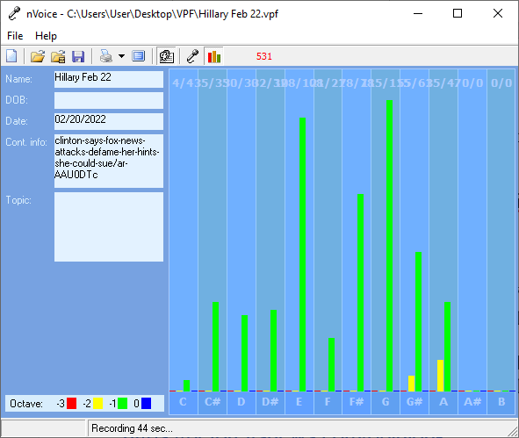

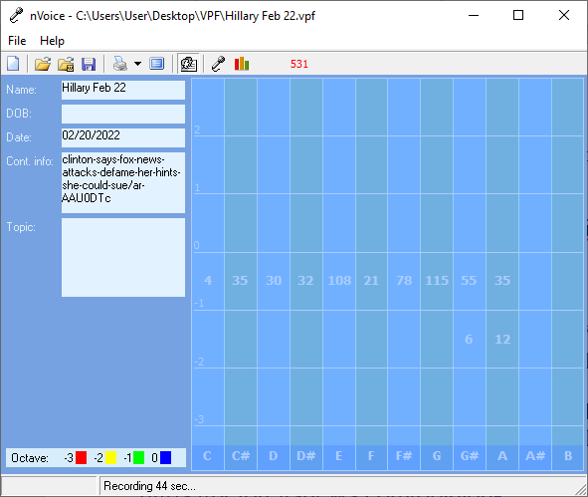
Hillary Feb 22

Recording Date: 02/20/2022

Missing Notes

You have no hits for the note(s) of: A#, B. Either you did not take enough samples (100-500 is usually best) or your subject matter did not include thoughts or topics that would involve this/these note(s). See the Note Correlate Chart that appears on the Cover Page for more explanation.

Points of Importance, Attention and Consequence

You know where your physical things are located even when others can't understand your system. You like control of your physical environment. Your stamina to get things accomplished is admirable. You have the ability to use words to persuade the minds of others. If you ever had to lie to see justice done, you would do it but your sense of justice does not always jive with the law. Using vocal expressions to misdirect a query is easy for you. You can use the high or low of your voice to give people direction as to how to treat you. You can convey a great variety of expressions using vocal nuance instead of words. You push yourself and others to finish the job. You love new ideas that mean you can have a project to work on. A sense of belonging is important to you Your highest note is associated with the expression of what you consider to be your physical domain. Having dominion over your physical environment resides with this note. Your highest note deals with expression through words both written and oral. The world of creative self-expression resides with this note. Your highest note is associated with the expression of duty to work and accomplishment. The ability to see the flaws in a plan and make it right resides with this note.

Sometimes you think you might as well be invisible when you spend your energy to help others because they don’t seem to be listening at the moment. You want to do something about the mess the world is in but just don't seem to have the energy. Your leadership ability is hampered by lack of opportunity. Note that thinking about an action is not the same as doing it, so go ahead a send that little gift, card or note. You like pointing out the mistakes of others but sometimes have a hard time receiving the same type of constructive criticism. You like nice things in your life. You admire people who you think have "class". You can sometimes do too much for others in the hopes of helping them change. You do for others before you do for yourself. It is a struggle sometimes to decide what you really think and what part belongs to someone else because you are so empathetic. Defining your own ideals and what you want from life is the first step to not following a wrong road. You can see what is the best for others but sometimes ignore what is the best for you. You tend to learn by example

Points of Communication, Complications and Complaints

Being able to appreciate your environment is important to you. Comfort in your environment needs to be balancing with pleasing colors and functionality. You like your working environment to be efficient with things readily available.

You have the ability to convince others with words - spoken and written. You have the ability to use words very creatively. You have the ability to inspire people using stories and demonstrations. You can think well and spontaneously when the need arises. You can change mental direction in a heartbeat.

You are capable of pushing yourself to get things done. Creating new projects from the ideas you generate is rewarding. You take pleasure in changing things for the better.

You like to contemplate an issue before you speak up. You are sometimes reluctant to take the lead. You have good ideas but are sometimes reluctant to speak up. You like the idea of leadership but sometimes take on more than you expected to contribute.

You know how to get things done but don't always have the time to deal with the details. Remember that planning something is not the same as getting something done. Thinking and doing needs more balance.

You can be talked out of your own opinions if solid evidence is presented because you are open to new ideas. You can sometimes feel criticism too quickly and too personally because you want to be more aware of your self issues. You can be very hard on yourself - taking blame or responsibility - that does not really reside with you. You sometimes fail to defend yourself because you don't want to criticize the opinions of others. In your desire to be of value to the growth of others you will learn that doing for others too quickly is not good for them.

Points of Cooperation, Learning, Opportunity and Growth

You are willing to spend a lot of your time making sure that others learn about integrity, wisdom and responsibility. You challenge yourself much more than others challenge you. You love seeing all the pieces fall together to make it all work.

Getting to the core of what you really believe to be the right way of life is important to you.. It is important to you that you make a difference in the lives of others.

You won't generally interfere unless it involves someone you care about. You can hold a grudge until you figure out how to make things right both physically and emotionally. You don't easily forgive although others may think you do.

You work to see that others are not taken advantage of. Writing that flows freely to you can also help move others towards their own inner strength. Your self-approval depends on living from the inside out - from the core of your being. You have a great ability to learn from your own mistakes and move on.

You actively support equal rights in words, in deed and money - when you have it. You have the ability to use self-power and self-approval as a potent combination to change opinions. You can be very persuasive when it comes to convincing people that their opinions and ideas are right/wrong. You have a balanced sense of self-worth.

You don't mind working to make your environment a place of enjoyment and peace. Working physically toward spiritual balance needs to be a part of your life. What others have is not a concern for you.

You want it done right the first time. You have the ability to see what won't work when others present you with a plan. You like verbal excitement via words and music.

You have a low tolerance for meaningless conversation. You have lots of ideas but prefer to keep them to yourself until you have worked them out completely. Even when you know someone is lying you feel uncomfortable confronting them. You would like the world to be a fair place without the need for arguments.

You are often too busy to think about or plan for the unexpected. Carrying the burden of thinking about it all and doing it all at the same time is heavy. Stress about getting things done can keep you from having the energy to complete the task.

Being aware of how others will take what you say is of concern to you. You have a knack for teaching by demonstration. You can easily take charge of a physical situation using words.

The balance of pride and a love of humanity keeps you committed and more busy than you would like. You can lose interest in a project without warning. You are likely to be put into a position to require others to finish projects because you spread yourself too thin.

You are hit hard at a soul level when justice does not prevail. You actively want to bring spiritual law to your life. Contemplation of what you want for your life and those around you will bring peace of spirit. Trusting in spirit may come hard for you or may be too easy because you jump from not questioning to total questioning. Balance between Truth and Spirit must come from within. Listening to others will give you ideas but won't satisfy you.

There are indications that issues with cellular oxygenation may need monitoring. Identifying which foods are most compatible with you is important to your digestive health. The process of digestion needs to be considered via enzyme evaluation.

