https://www.youtube.com/watch?v=V3g1xyDBs_s
Biden defended the ethical implications of his private ventures in an interview with ABC News, but conceded a political “mistake.”
Watch Part 2 here: https://gma.abc/2MinO1u Exclusive: 'I'm here': Hunter Biden hits back at Trump taunt in exclusive ABC News interview https://abcn.ws/2VHh1Sd

https://www.youtube.com/watch?v=V3g1xyDBs_s
As President Donald Trump continues to fill his Twitter feed and campaign speeches with attacks on Hunter Biden over his foreign business deals, the former vice president’s son defended the ethical implications of his private ventures in an interview with ABC News, but conceded taking a misstep in failing to foresee the political implications on his father’s career.

Doesn’t think anything wrong with his actions. Is separated into naïve, fantasy and omnipotent layers. Thinks he will be protected from reality of his actions. Weak point – has no respect for truth and justice.
Living in a fantasy world

Hunter Biden

Recording Date: 10/14/2020

Points of Importance, Attention and Consequence

You want everything done but you do so much that some things don't get done on time. You can be fussy about your physical space. It needs to satisfy you and no one else. Sometimes you spend a lot of energy trying to get even the smallest detail right the first time. You push yourself and others to finish the job. You love new ideas that mean you can have a project to work on. A sense of belonging is important to you. You appreciate others who recognize your ability to be of service. You have high ideas and expect the same of others. Sometimes there is conflict between your inner ideals and what you want others to think of you Your highest note is associated with the expression of physically prioritizing what you need and want to accomplishment. Personal control over what happens in your physical environment resides with this note. Your highest note is associated with the expression of duty to work and accomplishment. The ability to see the flaws in a plan and make it right resides with this note. Your highest note is associated with the expression of service to humanity and human spirit. Your feelings and desire to help others resides with this note

The demands on your life don't leave enough time for you personally. It is important to consider how your actions influence others. When confronted with what may be untrue, have the courage to go to the source and ask for clarification. You sometimes depend on others to support your place in the world. You can see how a situation needs to play out but you don't want to seem interfering. You don't always express your sense of confusion to the appropriate person when others attempt to deal with you inappropriately. Note that thinking about an action is not the same as doing it, so go ahead a send that little gift, card or note. You like pointing out the mistakes of others but sometimes have a hard time receiving the same type of constructive criticism. You like nice things in your life. You admire people who you think have "class"

Points of Communication, Complications and Complaints

You have the ability to organize and prioritize in your head. It may not look that way to others but it is your mode of operation. You like to organize yourself so that everything is at hand and easy to utilize. It is particularly bothersome when people use or borrow your property without permission.

You are capable of pushing yourself to get things done. Creating new projects from the ideas you generate is rewarding. You take pleasure in changing things for the better.

Seeing every side of an issue is important to making the right decision that is for the betterment of all concerned. You can easily put yourself aside for the benefit of others. You can be good counsel for others if you allow them to keep their own systems in tact and not insist they follow yours.

Your spiritual side may be neglected because of the responsibilities you hold. Taking time for yourself is important but you don't often do it. Allowing all that you do to be for the benefit of all concerned, even if it stresses your personally, is the best solution for you in the long run.

You don't always know how to fight back to secure what is properly your due. It is hard for you to understand why people take your peaceful nature as being an easy target. As long as a rule doesn't pertain to you or yours personally, you don't often bother to object. You very much appreciate those who come to your verbal rescue.

You can find what you need so organization isn't really necessary. You can get by with what is functional. You sometimes ignore what needs to be done and just do what pleases you.

Points of Cooperation, Learning, Opportunity and Growth

You love truth and justice and try hard to see that people are compensated for their efforts. You love a happy ending and like to think the world is fair and balanced. Your strong sense of justice needs a cause/outlet. You are more likely to fight for the rights of others than for yourself.

You have a tendency to fight authority particulary when you perceived that others are being threatened. You work hard to see that justice is instilled in those around you. You can become physically weak when people take advantage of you or yours but only after you have taken care of the situation. You love justice and truth and work hard to see that these qualities are upheld. You love a happy ending that includes justice, physical restitution and emotional fulfillment.

You like reciprocal relationships but often give more than you receive. You can be incredibly generous if your generosity is appreciated. You give of your time and organizational skills easily for a good cause.

You have a natural knack for planning. You like helping others do for themselves. Working for a cause usually puts you out front because of your organizational skills.

You share easily but dislike it when people take. You sometimes depend on what you did in the past to carry you through to the future. You can be disorganized but strive to not think about how others might judge you.

You work to see that others are not taken advantage of. Writing that flows freely to you can also help move others towards their own inner strength. Your self approval depends on living from the inside out - from the core of your being. You have a great ability to learn from your own mistakes and move on.

You can use words to help others find their path. You can go to a deep internal space using self dialogue. You can talk others into carrying out the details. You can envision an end result but don't want to be required to explain everything in detail.

You like to plan by talking about how things are to be done. Discussions about people's motives are a source of inspiration. You like to be creative but like to try your ideas out with someone you trust first. You are tolerate of long winded people because you can see through their pretense to their needs. Your self esteem come from what you accomplish. You don't tolerate fools who repeat information they can't defend.

You like to get things done but need a plan first. You don't like people interfering with the way things need to get done. You don't mind helping but you don't what to be kept to a schedule or plan that is not your own.

You have good intention about bringing your plans to fruition. You seem disorganized to the casual onlooker. You would like more options about your physical surroundings.

You are often too busy to think about or plan for the unexpected. Carrying the burden of thinking about it all and doing it all at the same time is heavy. Stress about getting things done can keep you from having the energy to complete the task.

Spiritual justice is important to you. The idea that people choose their own lessons and punishment is valid for you. You work toward healing the gap between spiritual law and man's law. Your physical health is closely related to your spiritual health. What you want to do and what you feel obligated to do is often in conflict.

Doing for others gives you satisfaction. A balance between giving and receiving is not always easy for you. You often give more than you receive in return.

There are indications that issues with cellular oxygenation may need monitoring. Identifying which foods are most compatible with you is important to your digestive health. The process of digestion needs to be considered via enzyme evaluation.

The balance of pride and a love of humanity keeps you committed and more busy than you would like. You can lose interest in a project without warning. You are likely to be put into a position to require others to finish projects because you spread yourself too thin.

You strive to bring together what others think of you with what you think of yourself. You can second guess yourself in a heartbeat. You let others convince you that your feelings are in error because you care about them and their opinions.

Biden about his son

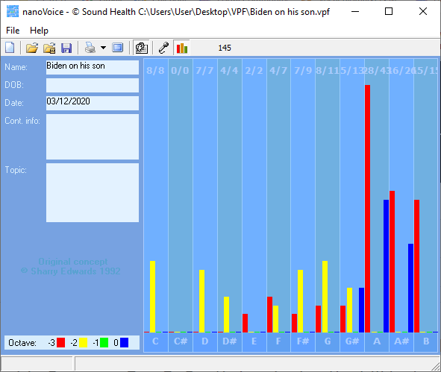
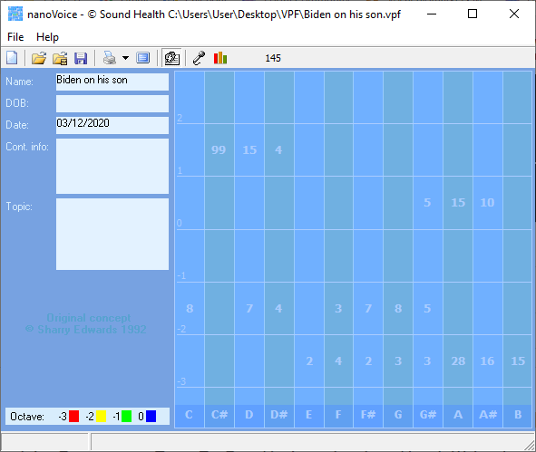

His ability to protect his son is a fantasy and he knows it. Is concerned about managing the future.

