Pelosi on 25 amendment announcement - https://www.msnbc.com/craig-melvin/watch/pelosi-claims-legislation-on-25th-amendment-is-about-continuity-of-government-93519941731
Pelosi intent: control of something physical
Her report on drugs is 41%, 79 hits – very high for some who is not a drug addict
Can’t determine her drug of choice – seems a mixed bag
Could some kind of drug cartel be behind her motivation
Also on brain drug
I’m surprised she is holding together
Strongest octave
Emotional with G (physical control) highest
Not ego driven
Lacks foundation
Weak point = F# - carry a plan to fruition
Justice is concentrated in Naïve fantasy
Scattered but holding it together
Most energy spent in physical issues of accomplishment
Likes he own intellectual ideas/plans
Left brained emotional but can use whole brain
Lots of mixed energy in note or E – breathing and expression of words
Conflict between justice and physical accomplishment

I don’t think this is about Trump – it is too scattered – her attack on Trump is usually very focused
This is beyond Trump to include her own ego – perhaps to use on Biden – if he wins, then she becomes VP to Camilla

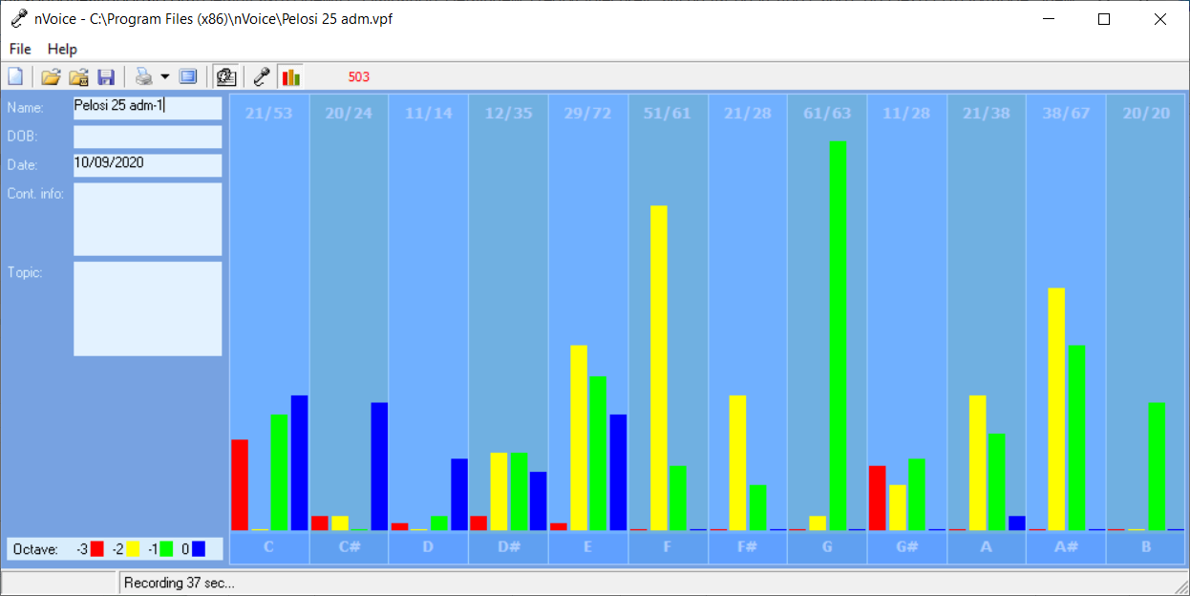

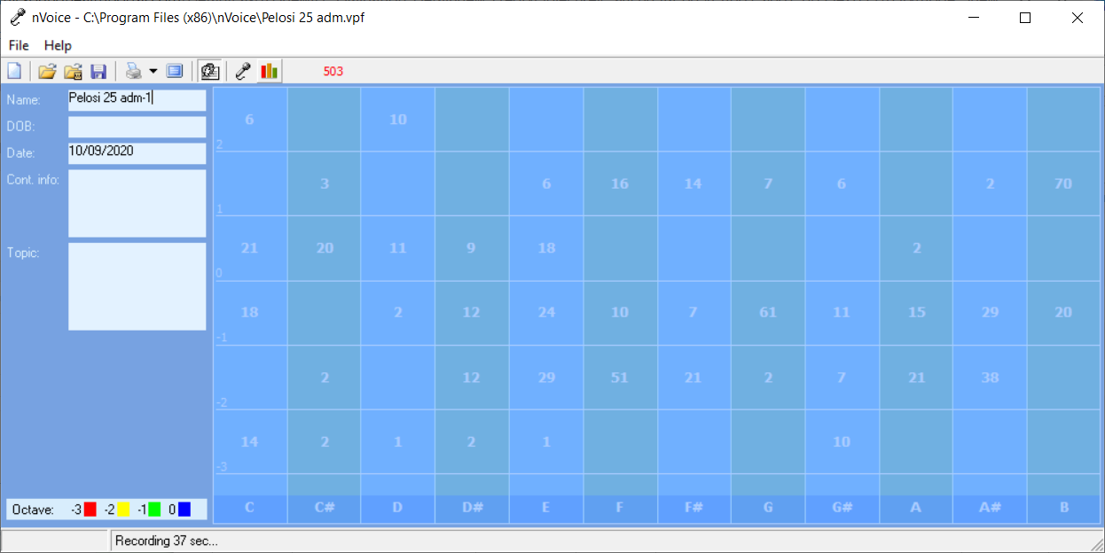
I let the computer do all of this – I did nothing by hand.
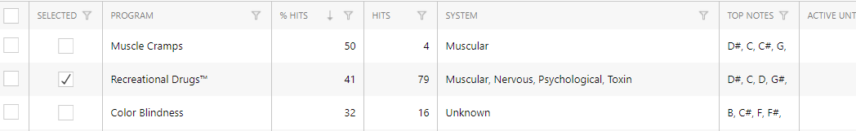

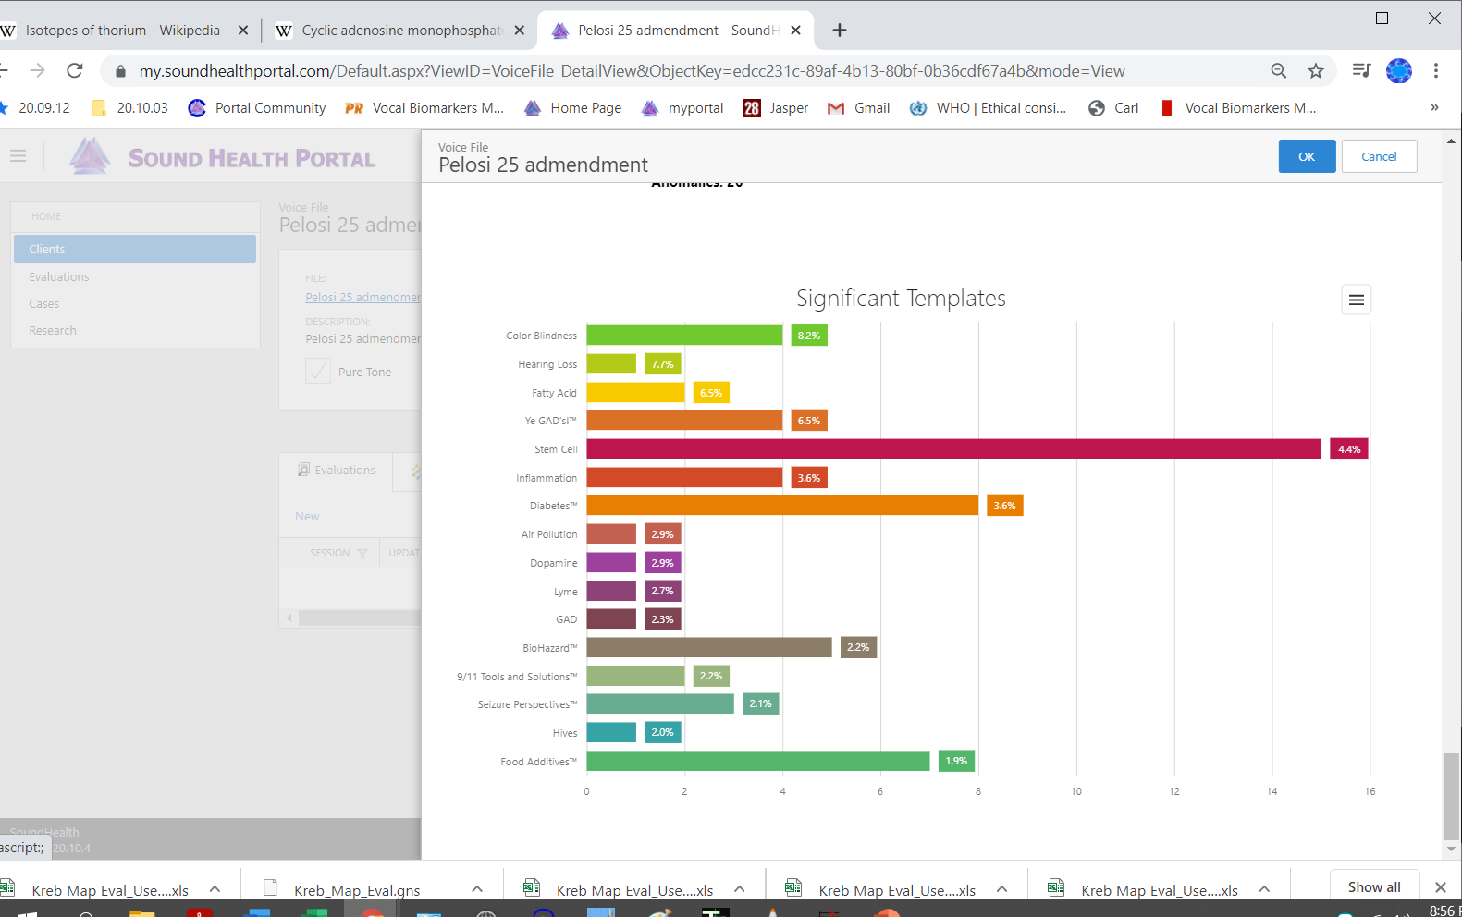
computer eval

Pelosi 25 adm-1

Recording Date: 10/09/2020

Points of Importance, Attention and Consequence

You know where your physical things are located even when others can't understand your system. You like control of your physical environment. Your stamina to get things accomplished is admirable. You plan well and want to see to it that your plans are carried out. It is easy for you to see the faults in others but don't always know how to get your point across politely. You expect others to take your suggestions seriously and gracefully. Nice things appeal to you and you are not averse to working hard to obtain them. It is important to you that spirituality be a part of everyday life. You think that feeding the mind is just as important as feeding the body. You are aware of how painful thoughtless words can be Your highest note is associated with the expression of what you consider to be your physical domain. Having dominion over your physical environment resides with this note. Your highest note is associated with the expression and integration of appropriate perception and action. The ability to assess a situation quickly resides with this note. Your highest note is associated with the expression of your internal perspective of service to self vs. humanitarian needs. The spirit of your inner core resides with your ability to take quiet time for yourself

Your ability to just "kick back" can cause stress for those around you. Some days it just feels good to sit back and do nothing. Having someone help you get started gets the job done faster. You can sometimes do too much for others in the hopes of helping them change. You do for others before you do for yourself. It is a struggle sometimes to decide what you really think and what part belongs to someone else because you are so empathetic. Defining your own ideals and what you want from life is the first step to not following a wrong road. You can see what is the best for others but sometimes ignore what is the best for you. You tend to learn by example. You are often haunted by thoughts of what you should have done. You may be caught once in a situation but you aren't often caught twice without a proper answer. You are often distressed by verbal arguments and loud talking. People who use their position of authority to manipulate others disturb you to a point of action. You often think you should do more than you have time to accomplishment

Points of Communication, Complications and Complaints

You have the ability to convince others with words - spoken and written. You have the ability to use words very creatively. You have the ability to inspire people using stories and demonstrations. You can think well and spontaneously when the need arises. You can change mental direction in a heartbeat.

You seek guidance from many sources both inside and outside of yourself. Spirituality in all that you do is important to you. You actively seek to bring spirit into your interactions with others.

Being able to appreciate your environment is important to you. Comfort in your environment needs to be balancing with pleasing colors and functionality. You like your working environment to be efficient with things readily available.

You can be talked out of your own opinions if solid evidence is presented because you are open to new ideas. You can sometimes feel criticism too quickly and too personally because you want to be more aware of your self issues. You can be very hard on yourself - taking blame or responsibility - that does not really reside with you. You sometimes fail to defend yourself because you don't want to criticize the opinions of others. In your desire to be of value to the growth of others you will learn that doing for others too quickly is not good for them.

Your connection to universal truths can be easily misplaced if you allow others to demand your time. Deciding to put yourself first may require considerable contemplation. Being proactive will lead you where you want to be. You like to see what others think and then add your opinion later. You have the ability to put yourself aside for others and often do.

You don't always know how to fight back to secure what is properly your due. It is hard for you to understand why people take your peaceful nature as being an easy target. As long as a rule doesn't pertain to you or yours personally, you don't often bother to object. You very much appreciate those who come to your verbal rescue.

Points of Cooperation, Learning, Opportunity and Growth

You have the ability to perceive what others may be thinking and can use it to your benefit. Your verbal skills make you a good trainer. You have the ability to play word games. You would make a good mediator.

You dislike being accused of something you did not do because it hurts your spirit. When you are satisfied with your decision, you no longer need to talk about it. You have the ability to influence others from a spiritual perspective.

You are willing to spend a lot of your time making sure that others learn about integrity, wisdom and responsibility. You challenge yourself much more than others challenge you. You love seeing all the pieces fall together to make it all work.

Getting to the core of what you really believe to be the right way of life is important to you. There are times when you disregard your own needs in order to help others. It is important to you that you make a difference in the lives of others. To help them move toward a more unselfish life. You are a natural teacher by example. You have a patient outlook on life and can work toward a specific goal without regard for your own needs.

You can use words to help others find their path. You can go to a deep internal space using self dialogue. You can talk others into carrying out the details. You can envision an end result but don't want to be required to explain everything in detail.

You don't mind working to make your environment a place of enjoyment and peace. Working physically toward spiritual balance needs to be a part of your life. What others have is not a concern for you.

You do for others just because they ask not because they deserve your time. You do for others more quickly than you do for yourself. Helping people grow emotionally is rewarding to you.

You have a low tolerance for meaningless conversation. You have lots of ideas but prefer to keep them to yourself until you have worked them out completely. Even when you know someone is lying you feel uncomfortable confronting them. You would like the world to be a fair place without the need for arguments.

You have good intention about bringing your plans to fruition. You seem disorganized to the casual onlooker. You would like more options about your physical surroundings.

You have the ability to see what needs done and give direction to completed the task. You have the ability to visualize yourself in other places and situations and often use this ability to plan your actions. You can physically breathe yourself through stressful situations.

Your self approval often depends on how satisfied you are with what you have accomplished. You work to please yourself by your accomplishments not necessarily for money or reward. You gain self approval by helping others gain self reward. People often come to you to clarify their own thoughts. You shine when you are being appreciated.

You can get involved quickly without knowing all the facts when you perceive an injustice. Those around you attempt to influence you through your emotions. When you think what has happened is unfair, your first thought is to make things right. You do this without thinking about how your actions will be perceived.

The desire and ability to be a leader is not often recognized until you speak up. You don't always do things because you want to but because it is expected of you. You tend to give too much or too little of yourself. Reciprocal appreciation is important to you.

You plan well but are sometimes short on the follow through because there just doesn't seem to be enough time to get it all done. The cooperation of others is essential to accomplish all that you conceive. You limit yourself with impatients when others get in the way of your plans.

