Pete Buttigieg
Talks about infra structure and bragging on Kamala Harris

https://www.youtube.com/watch?v=y8LcYRn_AcM
voice similar to Hillary a few years ago
Intellectual – frat boy
Talk and plan about physical but lack energy to manage anything

Lacks self ego – lacks self justice – could be molded easily
Lack foundational ideas - follower
Very little emotion

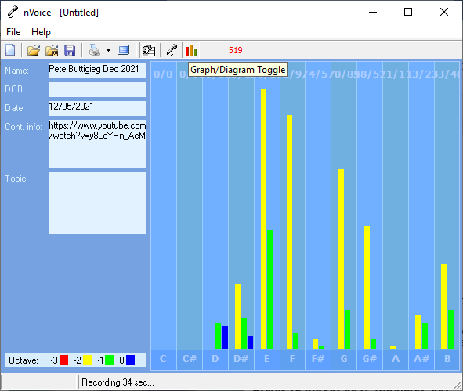
Pete Buttigieg Dec 2021

Recording Date: 12/05/2021

Missing Notes

You have no hits for the note(s) of: C, C#. Either you did not take enough samples (100-500 is usually best) or your subject matter did not include thoughts or topics that would involve this/these note(s). See the Note Correlate Chart that appears on the Cover Page for more explanation.

Points of Importance, Attention and Consequence

You have the ability to use words to persuade the minds of others. If you ever had to lie to see justice done, you would do it but your sense of justice does not always jive with the law. Using vocal expressions to misdirect a query is easy for you. You can use the high or low of your voice to give people direction as to how to treat you. You can convey a great variety of expressions using vocal nuance instead of words.

You plan well and want to see to it that your plans are carried out. It is easy for you to see the faults in others but don't always know how to get your point across politely. You expect others to take your suggestions seriously and gracefully. Nice things appeal to you and you are not averse to working hard to obtain them. You know where your physical things are located even when others can't understand your system. You like control of your physical environment. Your stamina to get things accomplished is admirable Your highest note deals with expression through words both written and oral. The world of creative self-expression resides with this note. Your highest note is associated with the expression and integration of appropriate perception and action. The ability to assess a situation quickly resides with this note. Your highest note is associated with the expression of what you consider to be your physical domain. Having dominion over your physical environment resides with this note

Being able to prioritize what needs to be done emotionally is not always easy for you. You have the ability to just shut down when you are overwhelmed. Your metabolism shows be a weak point in your vocal print. Your motivation is mostly mental. Ideas come to you in very odd moments when you are distracted by a required task. It would take a lot of planning to get everything done that you want to accomplish. You can sometimes do too much for others in the hopes of helping them change. You do for others before you do for yourself. It is a struggle sometimes to decide what you really think and what part belongs to someone else because you are so empathetic. Defining your own ideals and what you want from life is the first step to not following a wrong road. You can see what is the best for others but sometimes ignore what is the best for you. You tend to learn by example

Points of Communication, Complications and Complaints

You have the ability to convince others with words - spoken and written. You have the ability to use words very creatively. You have the ability to inspire people using stories and demonstrations. You can think well and spontaneously when the need arises. You can change mental direction in a heartbeat.

You have the ability to plan for yourself and others. You can easily show others how to put a plan together. You can get satisfaction out of being able to find and correct mistakes.

Being able to appreciate your environment is important to you. Comfort in your environment needs to be balancing with pleasing colors and functionality. You like your working environment to be efficient with things readily available.

You have a tendency to neglect your spiritual growth by maintaining too heavy a work load. You would like to have more time to spend on spiritual things. You have a hard time prioritizing what you want to do first.

You can easily be distracted from carrying out your plans by a more exciting prospect. You don't seem to have enough time and energy to get everything done that you want to accomplish. You would rather people come to you and ask for help instead of assuming you have the time to assist them.

You can be talked out of your own opinions if solid evidence is presented because you are open to new ideas. You can sometimes feel criticism too quickly and too personally because you want to be more aware of your self issues. You can be very hard on yourself - taking blame or responsibility - that does not really reside with you. You sometimes fail to defend yourself because you don't want to criticize the opinions of others. In your desire to be of value to the growth of others you will learn that doing for others too quickly is not good for them.

Points of Cooperation, Learning, Opportunity and Growth

You can use words to help others find their path. You can go to a deep internal space using self dialogue. You can talk others into carrying out the details. You can envision an end result but don't want to be required to explain everything in detail.

You have a low tolerance for meaningless conversation. You have lots of ideas but prefer to keep them to yourself until you have worked them out completely. Even when you know someone is lying you feel uncomfortable confronting them. You would like the world to be a fair place without the need for arguments.

You are often too busy to think about or plan for the unexpected. Carrying the burden of thinking about it all and doing it all at the same time is heavy. Stress about getting things done can keep you from having the energy to complete the task.

You have good intention about bringing your plans to fruition. You seem disorganized to the casual onlooker. You would like more options about your physical surroundings.

You have the ability to generate self healing. Using spirit to support your ideas is important. Exercise is particularly important to keep cellular oxygen flowing.

You plan well but are sometimes short on the follow through because there just doesn't seem to be enough time to get it all done. The cooperation of others is essential to accomplish all that you conceive. You limit yourself with impatience when others get in the way of your plans.

Stress can literally take your breath away. You have a tendency to promise more than you have time to deliver. You don't always have the energy to carry-out what you intended to do. You can get excited when you talk about an idea but can easily lose interest if you already know the outcome.

Your self power will increase when you begin to demand equal treatment. Your desire to help others can override your ability to accept from others. Always doing for others first is sometimes a lonely life.

