https://www.youtube.com/watch?v=z3Zv_8_f3rk
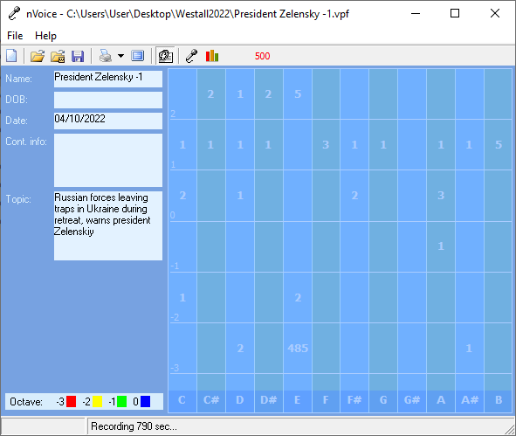
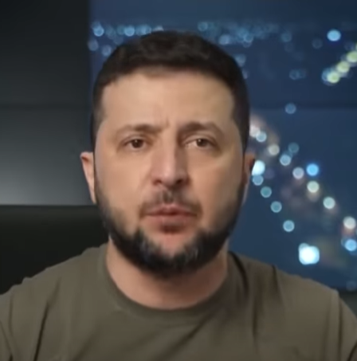
future oriented – Ukraine sacrificial lamb – feels deserted
voice prints indicate Putin and Biden on the same page
very concerned with words of support for his country
has strong belief in what he is saying
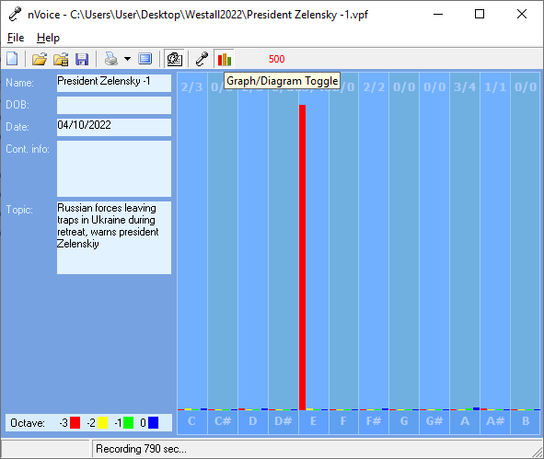
President Zelensky -1

Recording Date: 04/10/2022

Subject/Topic: Russian forces leaving traps in Ukraine during retreat, warns president Zelenskiy

Missing Notes

You have no hits for the note(s) of: C#, D#, F, G, G#, B. Either you did not take enough samples (100-500 is usually best) or your subject matter did not include thoughts or topics that would involve this/these note(s). See the Note Correlate Chart that appears on the Cover Page for more explanation.

Points of Importance, Attention and Consequence

You have the ability to use words to persuade the minds of others. If you ever had to lie to see justice done, you would do it but your sense of justice does not always jive with the law. Using vocal expressions to misdirect a query is easy for you. You can use the high or low of your voice to give people direction as to how to treat you. You can convey a great variety of expressions using vocal nuance instead of words. You have an unusual sense of time. Not having all the information needed to make a decision stresses you. Your reputation is very important to you. You will go to great lengths to protect it. You push yourself and others to finish the job. You love new ideas that mean you can have a project to work on. A sense of belonging is important to you Your highest note deals with expression through words both written and oral. The world of creative self-expression resides with this note. Your highest note is associated with the expression of your internal perspective of insight and self awareness. Internal faith, fairness and fulfillment reside with this note. Your highest note is associated with the expression of duty to work and accomplishment. The ability to see the flaws in a plan and make it right resides with this note

The demands on your life don't leave enough time for you personally. It is important to consider how your actions influence others. When confronted with what may be untrue, have the courage to go to the source and ask for clarification. You can sometimes do too much for others in the hopes of helping them change. You do for others before you do for yourself. It is a struggle sometimes to decide what you really think and what part belongs to someone else because you are so empathetic. Defining your own ideals and what you want from life is the first step to not following a wrong road. You can see what is the best for others but sometimes ignore what is the best for you. You tend to learn by example. Sometimes you think you might as well be invisible when you spend your energy to help others because they don’t seem to be listening at the moment. You want to do something about the mess the world is in but just don't seem to have the energy. Your leadership ability is hampered by lack of opportunity

Points of Communication, Complications and Complaints

You have the ability to convince others with words - spoken and written. You have the ability to use words very creatively. You have the ability to inspire people using stories and demonstrations. You can think well and spontaneously when the need arises. You can change mental direction in a heartbeat.

Your spiritual side may be neglected because of the responsibilities you hold. Taking time for yourself is important but you don't often do it. Allowing all that you do to be for the benefit of all concerned, even if it stresses your personally, is the best solution for you in the long run.

You can easily be distracted from carrying out your plans by a more exciting prospect. You don't seem to have enough time and energy to get everything done that you want to accomplish. You would rather people come to you and ask for help instead of assuming you have the time to assist them.

You like to contemplate an issue before you speak up. You are sometimes reluctant to take the lead. You have good ideas but are sometimes reluctant to speak up. You like the idea of leadership but sometimes take on more than you expected to contribute.

Points of Cooperation, Learning, Opportunity and Growth

You have a low tolerance for meaningless conversation. You have lots of ideas but prefer to keep them to yourself until you have worked them out completely. Even when you know someone is lying you feel uncomfortable confronting them. You would like the world to be a fair place without the need for arguments.

You want it done right the first time. You have the ability to see what won't work when others present you with a plan. You like verbal excitement via words and music.

You don't always take time for the spiritual side of life. Balance between spiritual and physical aspects of your being is important. You have the ability to allow your spirit to carry you when the body is weak.

Stress can literally take your breath away. You have a tendency to promise more than you have time to deliver. You don't always have the energy to carry-out what you intended to do. You can get excited when you talk about an idea but can easily lose interest if you already know the outcome.

The desire and ability to be a leader is not often recognized until you speak up. You don't always do things because you want to but because it is expected of you. You tend to give too much or too little of yourself. Reciprocal appreciation is important to you.

The balance of pride and a love of humanity keeps you committed and more busy than you would like. You can lose interest in a project without warning. You are likely to be put into a position to require others to finish projects because you spread yourself too thin.

