https://www.youtube.com/watch?v=8eVIDGIuQ-k
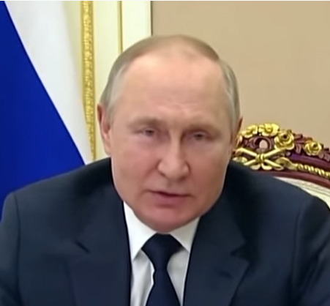
Putin in Russian about Ukraine war
Putin Russian language using nano

Very Surprised to see that Putin’s over all response is “for an emotional purpose” – how to hurt people emotionally best

Emotions and purpose in conflict

Very little ego involved. Convinced doing for others

A need for management based on emotional goal

Appears to be a bully with words but he has an emotional goal in mind dealing with physical outcomes.

A lot of imbalances dealing with words and actual plans
Conflict between emotional/spiritual goals and how to get there

Has a plan but lacks acumen about how to get there
Will do what appropriate to achieve emotional (beyond self) goals for a greater purpose.

Most like Hillary – trying to convince himself it is for someone’s elses purpose

Feels like he doesn’t have enough information

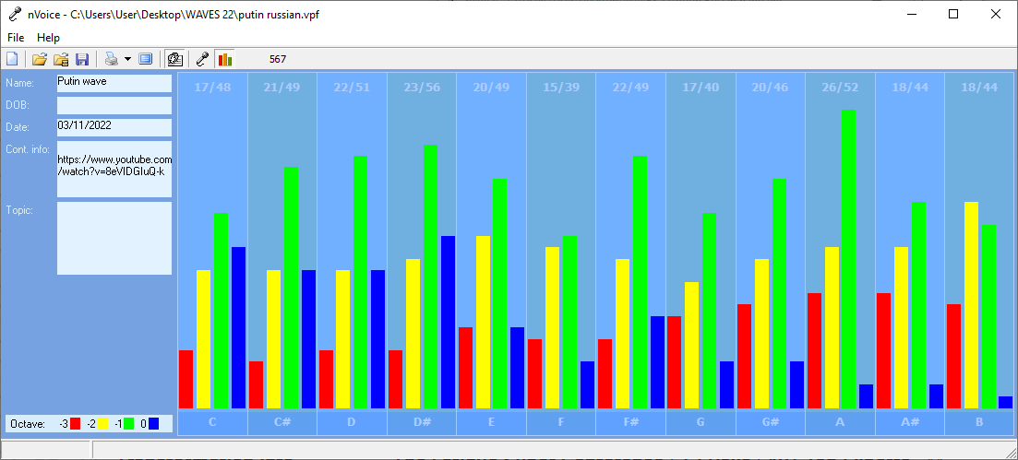Recording Date: 03/11/2022

Missing Notes

You have no hits for the note(s) of: B. Either you did not take enough samples (100-500 is usually best) or your subject matter did not include thoughts or topics that would involve this/these note(s). See the Note Correlate Chart that appears on the Cover Page for more explanation.

Print-out much like Hillary Clinton.

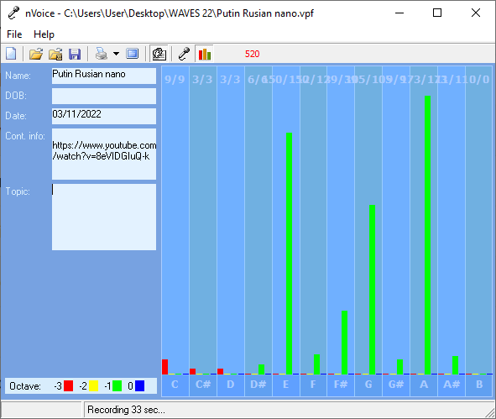
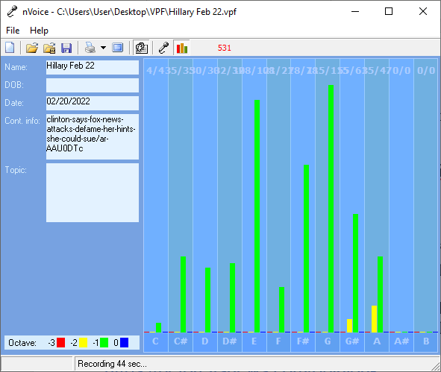

Points of Importance, Attention and Consequence

You have an unusual sense of time. Not having all the information needed to make a decision stresses you.

Your reputation is very important to you. You will go to great lengths to protect it.

You have the ability to use words to persuade the minds of others. If you ever had to lie to see justice done, you would do it but your sense of justice does not always jive with the law.

Using vocal expressions to misdirect a query is easy for you. You can use the high or low of your voice to give people direction as to how to treat you. You can convey a great variety of expressions using vocal nuance instead of words. You know where your physical things are located even when others can't understand your system. You like control of your physical environment. Your stamina to get things accomplished is admirable Your highest note is associated with the expression of your internal perspective of insight and self-awareness. Internal faith, fairness and fulfillment reside with this note. Your highest note deals with expression through words both written and oral. The world of creative self-expression resides with this note. Your highest note is associated with the expression of what you consider to be your physical domain. Having dominion over your physical environment resides with this note

You sometimes depend on others to support your place in the world. You can see how a situation needs to play out, but you don't want to seem interfering. You don't always express your sense of confusion to the appropriate person when others attempt to deal with you inappropriately. You can sometimes do too much for others in the hopes of helping them change. You do for others before you do for yourself.

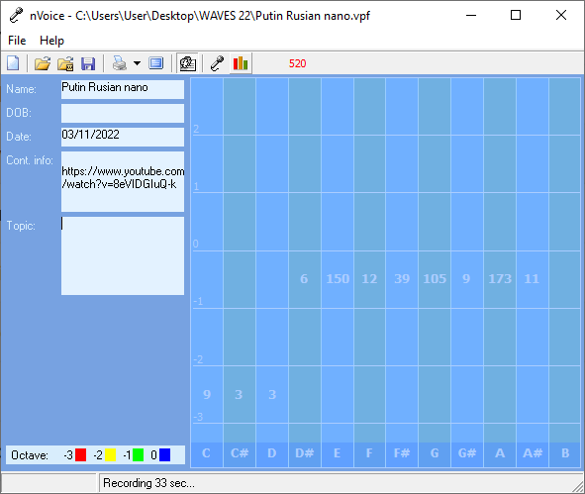
It is a struggle sometimes to decide what you really think and what part belongs to someone else because you are so empathetic. Defining your own ideals and what you want from life is the first step to not following a wrong road. You can see what is the best for others but sometimes ignore what is the best for you. You tend to learn by example. You are often haunted by thoughts of what you should have done. You may be caught once in a situation, but you aren't often caught twice without a proper answer. You are often distressed by verbal arguments and loud talking. People who use their position of authority to manipulate others disturb you to a point of action. You often think you should do more than you have time to accomplishment

Points of Communication, Complications and Complaints

Seeing every side of an issue is important to making the right decision that is for the betterment of all concerned. You can easily put yourself aside for the benefit of others. You can be good counsel for others if you allow them to keep their own systems intact and not insist, they follow yours.

You have the ability to convince others with words - spoken and written. You have the ability to use words very creatively. You have the ability to inspire people using stories and demonstrations. You can think well and spontaneously when the need arises. You can change mental direction in a heartbeat.

Being able to appreciate your environment is important to you. Comfort in your environment needs to be balancing with pleasing colors and functionality. You like your working environment to be efficient with things readily available.

You can be talked out of your own opinions if solid evidence is presented because you are open to new ideas. You can sometimes feel criticism too quickly and too personally because you want to be more aware of your self-issues. You can be very hard on yourself - taking blame or responsibility - that does not really reside with you. You sometimes fail to defend yourself because you don't want to criticize the opinions of others. In your desire to be of value to the growth of others you will learn that doing for others too quickly is not good for them.

You don't always know how to fight back to secure what is properly your due. It is hard for you to understand why people take your peaceful nature as being an easy target. As long as a rule doesn't pertain to you or yours personally, you don't often bother to object. You very much appreciate those who come to your verbal rescue.

You wish for the best which sometimes leads to statements of hope instead of statements of fact. You may need more than one chance to express yourself to get it right. Practice speaking your ideas before you enter into dialogue. Meditating about a situation or playing it over in your mind will clarify your stance and help you clearly represent your ideas. Being in stress will likely affect your breathing. You trust until you get hurt even though making people earn your trust is more logical.

Points of Cooperation, Learning, Opportunity, and Growth

You don't always take time for the spiritual side of life. Balance between spiritual and physical aspects of your being is important. You have the ability to allow your spirit to carry you when the body is weak.

Having time for inner thought is important to you. You often put others ahead of yourself. Inner dialogue is important to seeing who you want to be. Calling on the help of spirit can make your life lighter.

You have a low tolerance for meaningless conversation. You have lots of ideas but prefer to keep them to yourself until you have worked them out completely. Even when you know someone is lying you feel uncomfortable confronting them. You would like the world to be a fair place without the need for arguments.

You strive to bring together what others think of you with what you think of yourself. You can second guess yourself in a heartbeat. You let others convince you that your feelings are in error because you care about them and their opinions.

Stress can literally take your breath away. You have a tendency to promise more than you have time to deliver. You don't always have the energy to carry-out what you intended to do. You can get excited when you talk about an idea but can easily lose interest if you already know the outcome.

The balance of pride and a love of humanity keeps you committed and busier than you would like. You can lose interest in a project without warning. You are likely to be put into a position to require others to finish projects because you spread yourself too thin.

Translation of Putin to English

We know it well. They urge their citizens to tighten their belts, dress warmer and point to the sanctions they impose on us as a reason for their deteriorating situation. They try to blame the results of their own mistakes on us. We have already spoken on the energy sector and the problems they are trying to create for us in financial area, ones connected to financing certain deals, in logistics, insurance area - they are already affecting the energy sources pricing on many markets. We have the resources that we can and ready to provide to our foreign partners. Let me repeat - if they create some sort of problems for us then the negative consequences for this area of economy are unavoidable. They are just unavoidable. The prices will go even higher.

