Many Military U.F.O. Reports Are Just Foreign Spying or Airborne Trash
New York Times
Oct. 29, 2022

By Julian E. Barnes
WASHINGTON — Government officials believe that surveillance operations by foreign powers and weather balloons or other airborne clutter explain most recent incidents of unidentified aerial phenomena — government-speak for U.F.O.s — as well as many episodes in past years.
The sightings have puzzled the Pentagon and intelligence agencies for years, fueling theories about visiting space aliens and spying by a hostile nation using advanced technology. But government officials say many of the incidents have far more ordinary explanations.
Intelligence agencies are set to deliver a classified document to Congress by Monday updating a report made public last year that said nearly all of the incidents remain unexplained. The original document looked at 144 incidents between 2004 and 2021 that were reported by U.S. government sources, mostly American military personnel.
This article is based on interviews with American officials familiar with the findings of the Pentagon and intelligence agencies’ examination of the incidents. The officials spoke on the condition of anonymity to discuss the classified work.
Some of the incidents have been formally attributed to Chinese surveillance — with relatively ordinary drone technology — and others are also thought to be connected to Beijing. China, which has stolen plans for advanced fighter planes, wants to learn more about how the United States trains its military pilots, according to American officials.
Much of the information about the unidentified phenomena remains classified. While Congress has been briefed on some of the conclusions about foreign surveillance, Pentagon officials have kept most of the work secret — in large measure because they do not want China or other countries to know that their efforts to spy on the American military were detected.
But such official secrecy comes at a cost, allowing conspiracy theories about government lies to thrive unchecked.
Sue Gough, a Defense Department spokeswoman, said the Pentagon remains committed to principles of openness but must balance that with its “its obligation to protect sensitive information, sources and methods.”
While the Pentagon will not “rush to conclusions in our analysis,” Ms. Gough said, no single explanation addresses the majority of unidentified aerial phenomena reports.
“We are collecting as much data as we can, following the data where it leads and will share our findings whenever possible,” she said.
It was not clear how much of the new intelligence report would be made public. But of the cases that have been resolved, most have proved to be either errant junk in the sky, like balloons, or surveillance activity, officials said. Incidents recorded in the past year, for which more data has been collected, have turned out to have ordinary, earthbound explanations.
Officially, many of the older incidents are still unexplained and there is just too little data for Pentagon or intelligence officials to make final conclusions.
“In many cases, observed phenomena are classified as ‘unidentified’ simply because sensors were not able to collect enough information to make a positive attribution,” Ms. Gough said, referring to cameras, radar and other devices that collect information. “We are working to mitigate these shortfalls for the future and to ensure we have sufficient data for our analysis.”
Other officials insist that even though the evidence is imperfect, the grainy videos do not show space aliens.
Optical illusions along with the characteristics of classified sensors have caused ordinary objects, like drones or balloons, to appear to be something unusual or frightening.
In May, the Pentagon announced that previously released images of green triangles that looked like they could be alien ships were actually drones photographed through night-vision lenses.
Military officials declined to say precisely when or where the images were taken. But they believe the incidents are examples of attempts to conduct surveillance on military maneuvers.
U.F.O. skeptics and experts in optics have long said many of the videos and sightings by naval aviators represent optical illusions that have made ordinary objects — weather balloons, commercial drones — appear to move faster than possible.
Military officials have largely come to the same conclusion.
Besides the images of the green triangles, the other recordings released by the Pentagon have not been categorized as surveillance incidents, at least so far. But Pentagon officials do not believe that any of them represent aliens, either.
One of the videos, referred to as GoFast, appears to show an object moving at immense speed. But an analysis by the military says that is an illusion created by the angle of observation against water. According to Pentagon calculations, the object is moving only about 30 miles per hour.
Another video, known as Gimbal, shows an object that appears to be turning or spinning. Military officials now believe that is the optics of the classified image sensor, designed to help target weapons, make the object appear like it is moving in a strange way.
Pentagon analysts remain puzzled by some of the videos collected by the military. One where an object hovers over the water, jumps erratically, then peels away, is more difficult to explain, officials said. But analysts who have studied that video, as well as ones associated with eyewitness reports from aviators, are convinced it is not a piece of alien technology.
Nevertheless, efforts by the Pentagon or intelligence officials to stamp out theories about aliens have largely failed. The Pentagon has formed, and then reformed, groups inside the department to improve data collection around the incidents and provide better explanations.
Military officials have repeatedly said there is no evidence that any of the images show space alien visitors, comments often played down in the news media or ignored by lawmakers. In May, Pentagon officials testified under oath that the government had not collected materials from any alien landing on Earth. But the testimony did little to dampen enthusiasm for theories about extraterrestrial visitors.
Publicly, military and intelligence officials have been reluctant to offer alternative theories, in part because they lack complete information, like in the case of the three videos, or because they do not want to reveal what they know about the surveillance, for fear China or other countries could learn to better hide their activities.
The failure to categorize or offer explanations for many of the unidentified incidents has allowed U.F.O. enthusiasts to argue that the government does not know what the incidents are — at least leaving open the possibility that aliens have been visiting the United States.
There is a long history of the U.S. government using speculation over conspiracy theories to prevent secrets from becoming widely known. During the development of American spy planes like the U-2 and SR-71 Blackbird, the government allowed rumors about U.F.O. sightings to continue to help hide the development of those programs.
But intelligence officials concluded long ago that using conspiracy theories as cover for classified programs sows distrust in the American government and paranoia.
Some American officials believe the secrecy surrounding the Chinese surveillance of military bases once again risks giving life to conspiracy theories and heightening distrust of government in a ever more bitterly divided society.

At the hearing in May, the Pentagon declassified the conclusions about two separate images of ghostly green triangles recorded in two incidents, one on the East Coast and one on the West. Officials testified publicly that the green triangles were actually drones, with a trick of the camera lens and night vision technology transforming them into glowing triangles that look like alien spacecraft.
At the hearing, other military assets saw drones operating in the area, allowing the Navy to conclude the strange triangles were nothing otherworldly, said Scott W. Bray, the deputy director of naval intelligence.
At the hearing, Mr. Bray also explained why the government was not releasing more information about the incidents.
“We do not want potential adversaries to know exactly what we’re able to see or understand, or how we come to the conclusion,” Mr. Bray said. “Therefore, disclosures must be carefully considered on a case-by-case basis.”

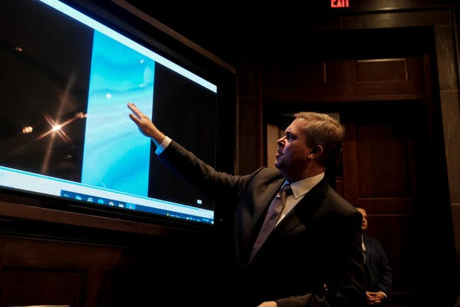
Scott Bray, the deputy director of Navy intelligence, briefing the House Intelligence Committee in May.Credit...Michael A. McCoy for The New York Times

