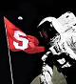 Stanford On The Moon Newsletter -- Winter 2020
Happy New Year / Happy New Decade !!
Barbara Honegger (Class of 1969) joined Stanford On The Moon Alumni Club and Advisory Committee in time to celebrate our 20th Anniversary. Barbara contributed the following article in which she describes her work at the White House and Dept. of Justice in the 1980s opening NASA’s Astronaut Corps to Women, including Nine Stanford Women Astronauts:
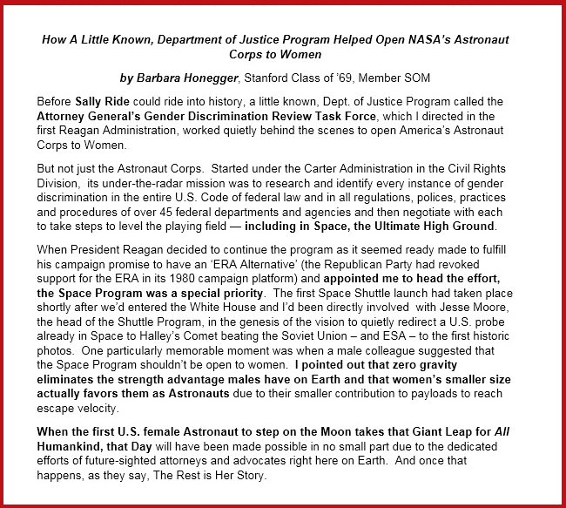Gi

