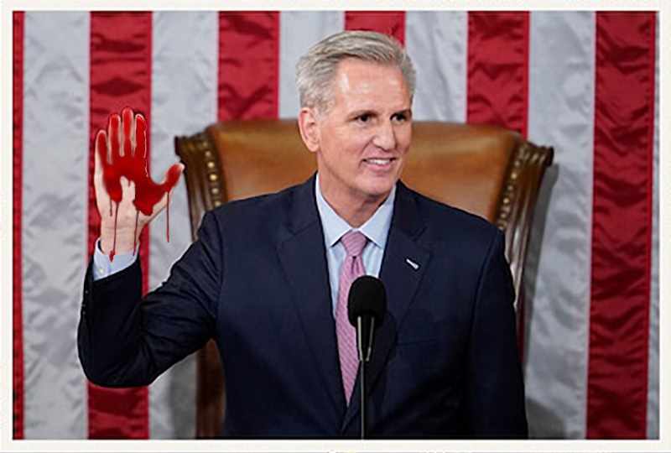
Kevin McCarthy, a divided GOP and the curse of Jan. 6 WPost -- January 7, 2023
There are 175 House Republicans who have in some way or another or at some time or another embraced Trump’s baseless claims about 2020. Some of the central players in the battle for House speaker were in the thick of efforts to overturn the election, as documented by the final report of the House select committee investigating the Jan. 6, 2021, attack on the Capitol ...
... On Friday, as Biden and congressional Democrats attended ceremonies marking the second anniversary of the attack and honoring the law enforcement officers who defended the Capitol during the siege and commemorating those who lost their lives, only a single House Republican, Rep. Brian Fitzpatrick of Pennsylvania, chose to attend. That is the political legacy of Jan. 6 for what once was dubbed the Grand Old Party ...
... McCarthy had to grapple with Rep. Matt Gaetz of Florida, who reportedly sought a preemptive pardon from Trump. His allies had to negotiate with Rep. Scott Perry of Pennsylvania, who pushed to install the controversial Jeffrey Clark as attorney general in the waning days of the Trump administration. He faced a holdout from Rep. Lauren Boebert of Colorado, who barely won her reelection and is on the far fringe of her party, until she finally voted “present” ...

